Title of the document. Text is:
Your PLANETS Translatable Glossary for:
Worlds Apart:
Engineering Remote Sensing Devices

You can add drawings and notes under the words to help remember their meanings.

# 

## Bird’s-eye view:

A perspective from above

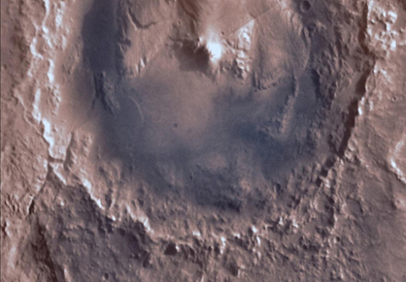

Bird’s eye view looking down on Gale Crater on Mars.  
(Source: NASA Viking Orbiter))

## Composition:

What a surface is made of

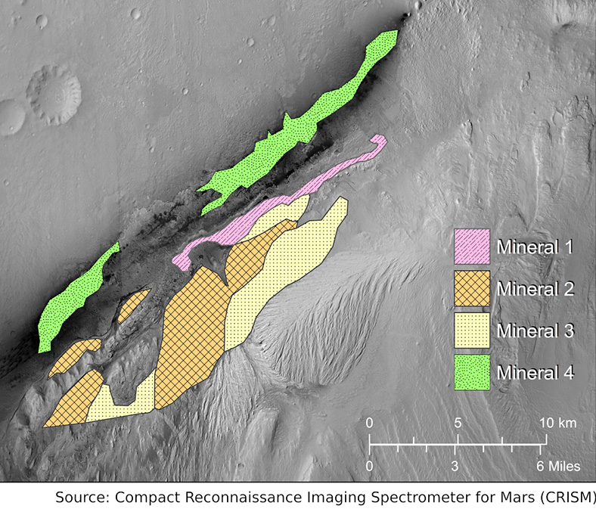

Mineral Map of Gale Crater Rim (Source: NASA CRISM & PLANETS)

## Constraints:

Limits on a design

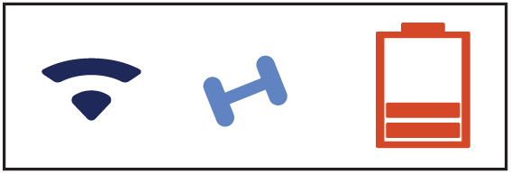

*Icons for communications, weight, and energy (Source: PLANETS)*

## Criteria:

Things a successful design needs to do or have



*Criteria checklist (Source: PLANETS))*

## Engineering design process:

A set of steps that engineers use to design things to solve a problem

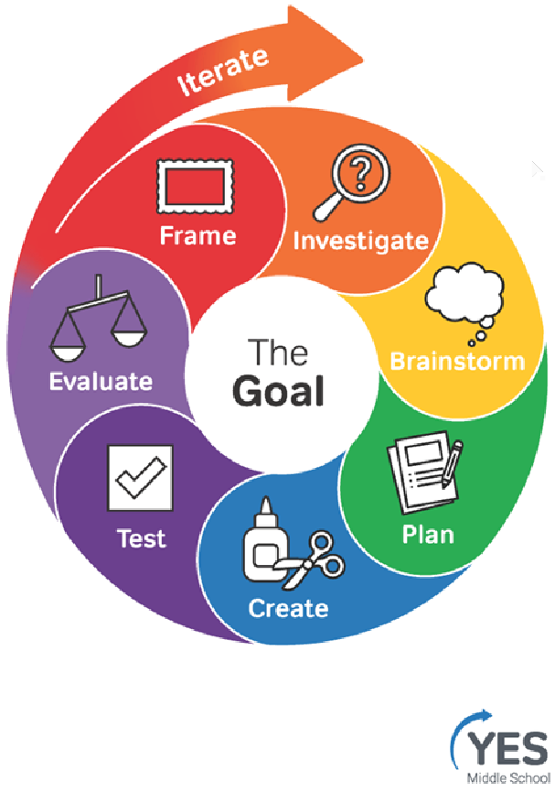

*Engineering Design Process (Source: YES, Museum of Science, Boston)*

## Fairing:

The part that sits on top of the rocket and protects a spacecraft during launch

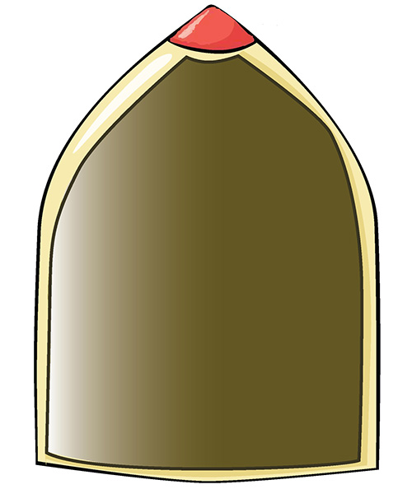

Cutout illustration of spacecraft fairing (Source: PLANETS)

## Filter:

A technology for blocking certain things and letting other things through

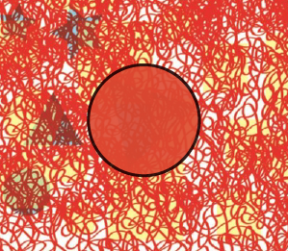

Red filter revealing hidden shapes (Source: PLANETS)

## Habitable:

Can or once could have supported some form of life

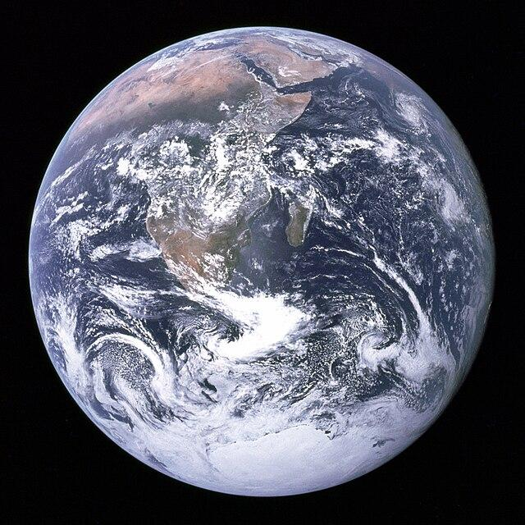

“The Blue Marble” Planet Earth (Source: NASA-Apollo 17)

## LiDAR:

Light detection and ranging, a technique that uses lasers to measure distance

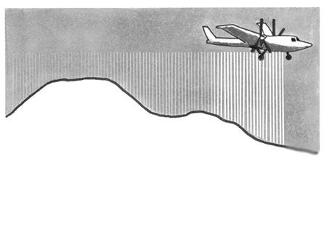

Illustration of airplane using LiDAR (Source: PLANETS)

## Mineral:

A naturally occurring crystal formed by geologic processes, with a specific chemical composition. Rocks are made of one or more types of crystal.

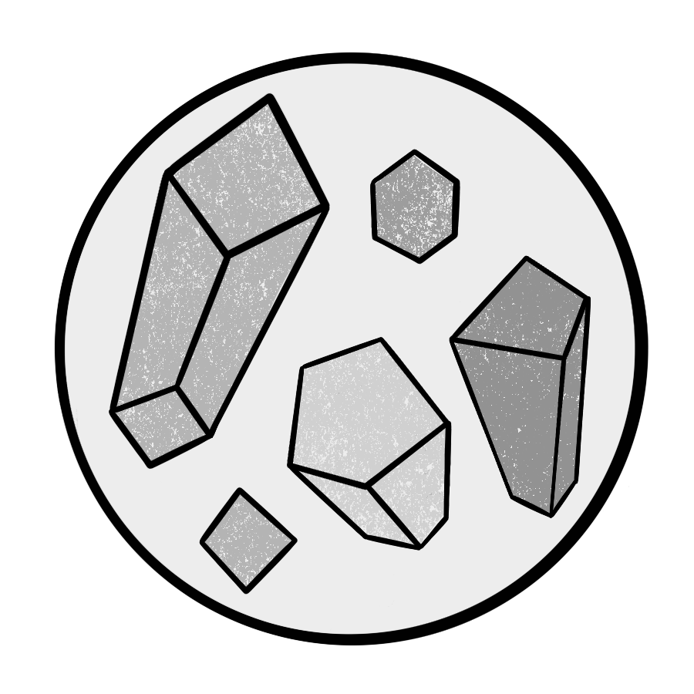

## *Minerals (Source: PLANETS)*

## Obstacle:

Anything that might be in the way



Cardboard Box (Source: PLANETS)

## Physical properties:

The shape and texture of a surface

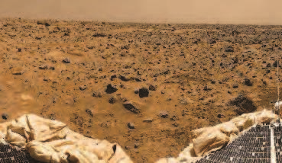

Surface of Mars (Image Credit: NASA/JPL- Pathfinder)

## Redirect:

To change the direction of something

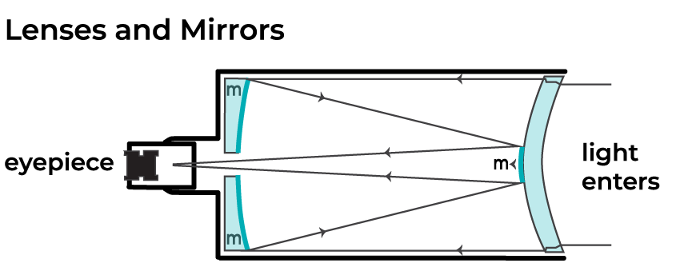

*Telescope Cutout (Source: PLANETS)*

## Remote:

Far away or distant

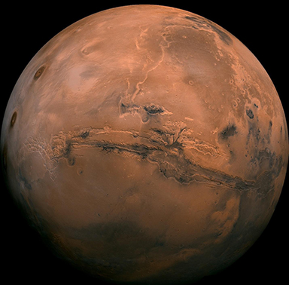

*Distant Planet Mars (Source: NASA/JPL-Caltech)*

## Remote Sensing:

Collecting information at a distance

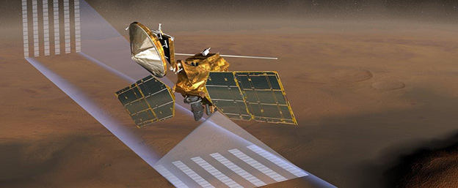

*Artist Rendition of Mars Reconnaissance Orbiter (MRO) collecting temperature, pressure, dust and water vapor concentration above Mars (Source: NASA / JPL)*

## Resolution:

The amount of detail in an image

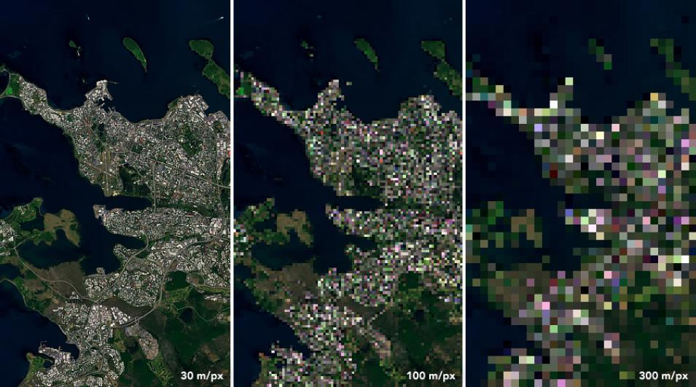

Landsat 8 image of Reykjavik, Iceland (Source: NASA Earth Observatory)

## Sensing:

Collecting or becoming aware of information

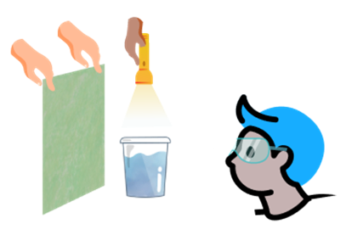

Seeing is one form of sensing (Source: PLANETS)

## System:

A group of parts that work together

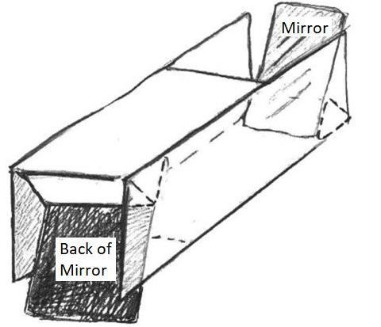

*Illustration of a light redirection system (Source: PLANETS)*

## Technology:

An object, system, or process designed by people to solve a problem

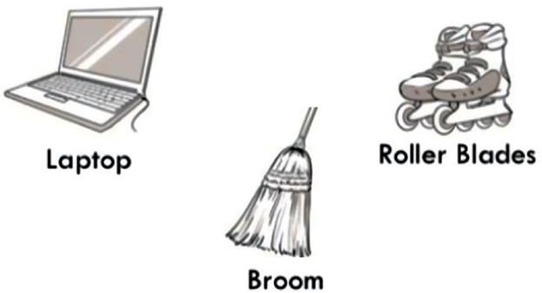

# *Everyday objects can be technology (Source: PLANETS)*

# 

## Topographic map:

A representation of the shape of land in an area

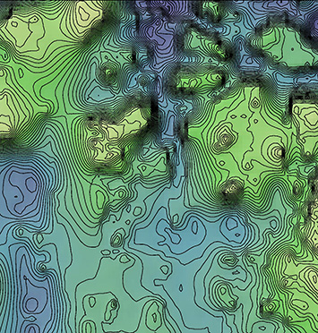

Topographic map of Iani Chaos landing site, Mars   
(Source: NASA/JPL-MOLA)

## Topography:

The shape of land in an area

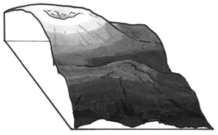

Cross-section of a mountain (Source: PLANETS)