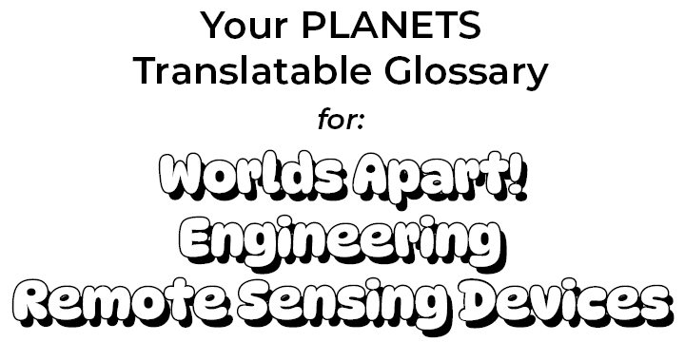
You can add drawings and notes under the words to help remember their meanings.

Bird’s-eye view:
A perspective from above
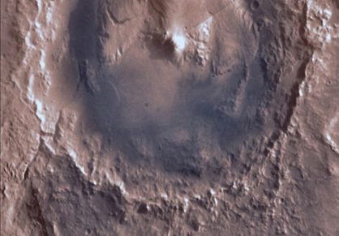
Bird’s eye view looking down on Gale Crater on Mars.
(Source: NASA Viking Orbiter))

Composition:
What a surface is made of
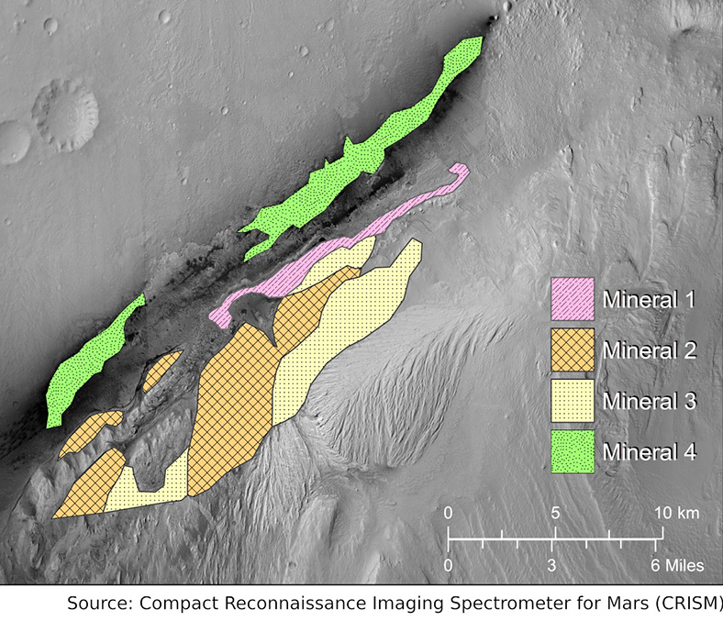
Mineral Map of Gale Crater Rim (Source: NASA CRISM & PLANETS)

Constraints:
Limits on a design
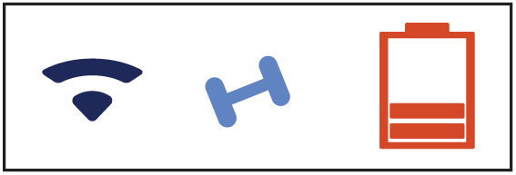
Icons for communications, weight, and energy (Source: PLANETS)

Criteria:
Things a successful design needs to do or have

Criteria checklist (Source: PLANETS))

Engineering design process:
A set of steps that engineers use to design things to solve a problem
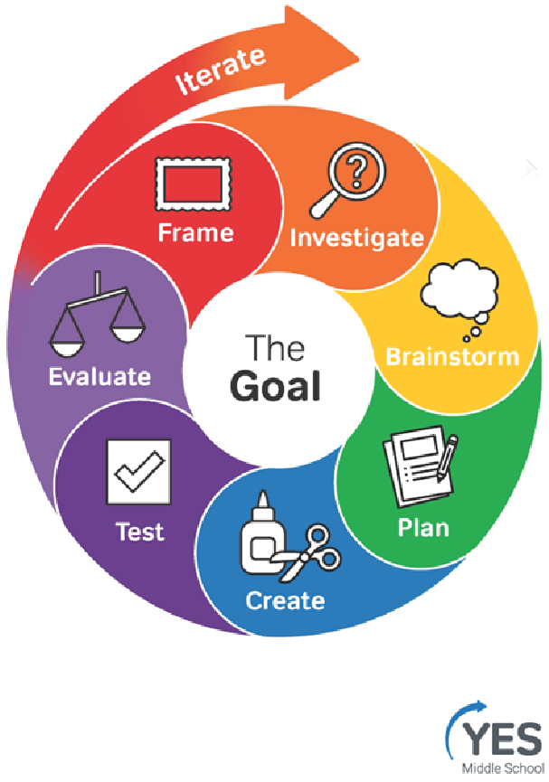
Engineering Design Process (Source: YES, Museum of Science, Boston)

Fairing:
The part that sits on top of the rocket and protects a spacecraft during launch
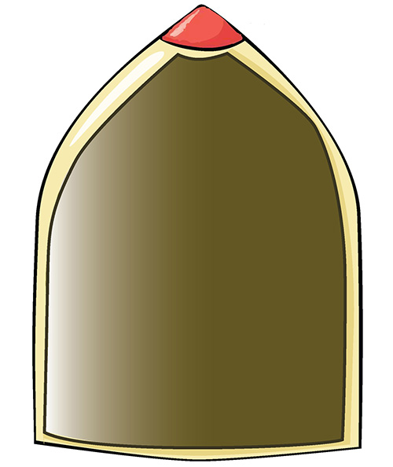
Cutout illustration of spacecraft fairing (Source: PLANETS)

Filter:
A technology for blocking certain things and letting other things through
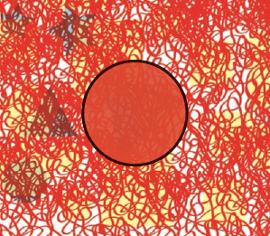
Red filter revealing hidden shapes (Source: PLANETS)

Habitable:
Can or once could have supported some form of life
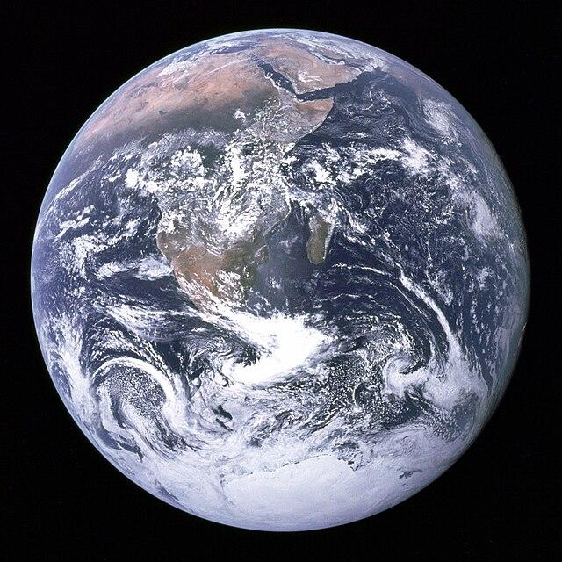
“The Blue Marble” Planet Earth (Source: NASA-Apollo 17)

LiDAR:
Light detection and ranging, a technique that uses lasers to measure distance
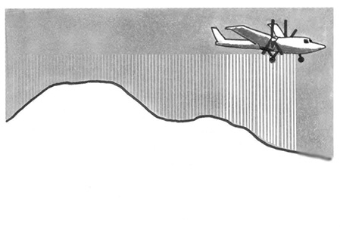
Illustration of airplane using LiDAR (Source: PLANETS)

Mineral:
A naturally occurring crystal formed by geologic processes, with a specific chemical composition. Rocks are made of one or more types of crystal.
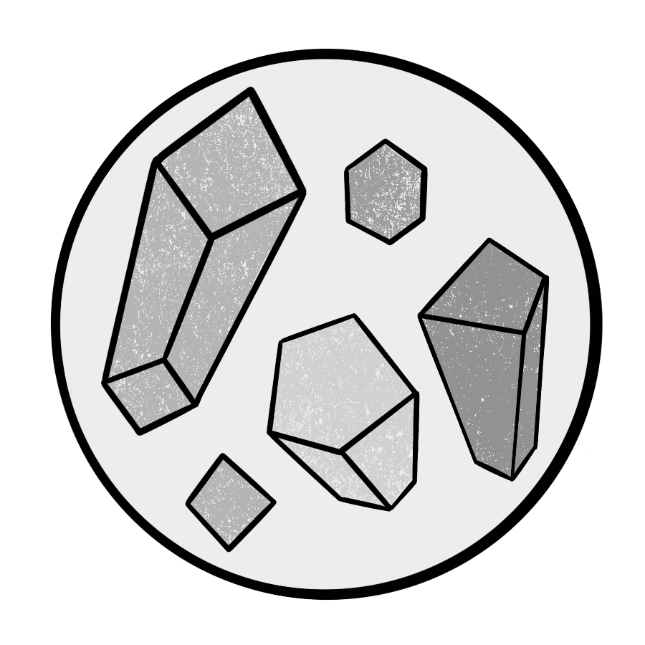

Minerals (Source: PLANETS)

Obstacle:
Anything that might be in the way
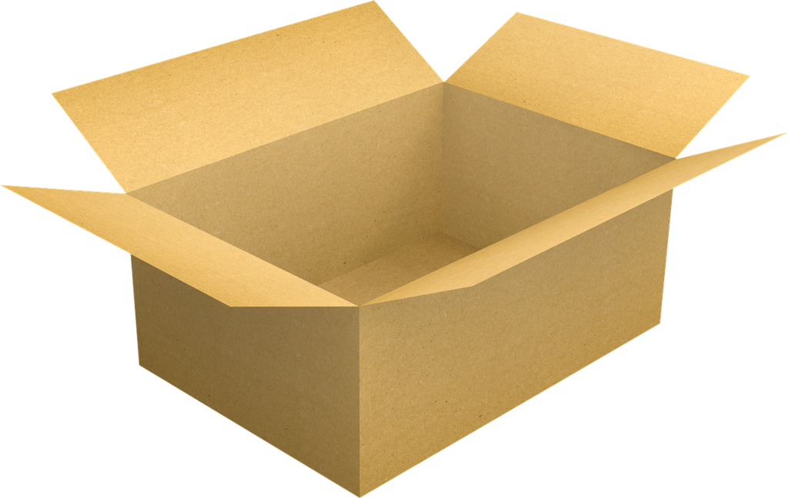
Cardboard Box (Source: PLANETS)

Physical properties:
The shape and texture of a surface
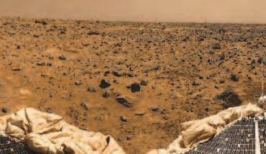
Surface of Mars (Image Credit: NASA/JPL- Pathfinder)

Redirect:
To change the direction of something
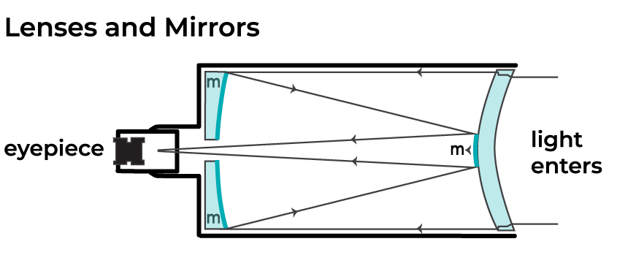
Telescope Cutout (Source: PLANETS)

Remote:
Far away or distant
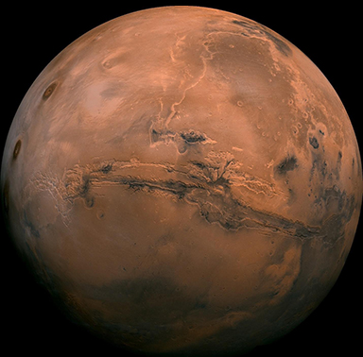
Distant Planet Mars (Source: NASA/JPL-Caltech)

Remote Sensing:
Collecting information at a distance
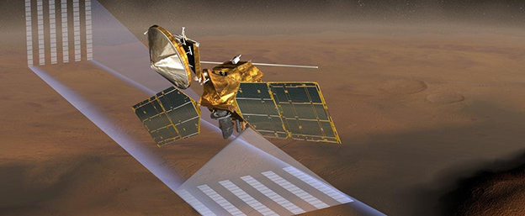
Artist Rendition of Mars Reconnaissance Orbiter (MRO) collecting temperature, pressure, dust and water vapor concentration above Mars (Source: NASA / JPL)

Resolution:
The amount of detail in an image
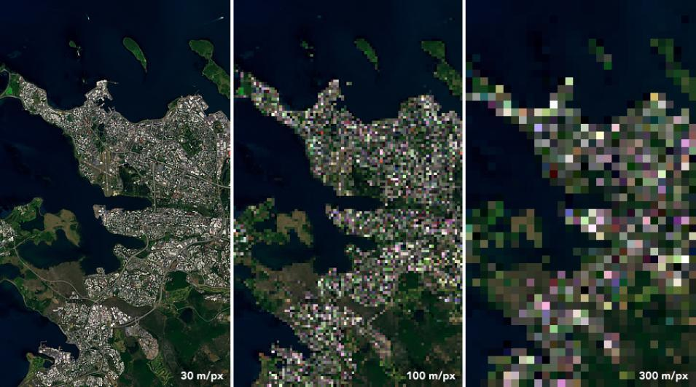
Landsat 8 image of Reykjavik, Iceland (Source: NASA Earth Observatory)

Sensing:
Collecting or becoming aware of information
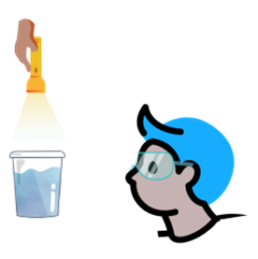
Seeing is one form of sensing (Source: PLANETS)

System:
A group of parts that work together
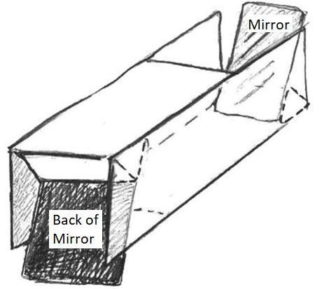
Illustration of a light redirection system (Source: PLANETS)

Technology:
An object, system, or process designed by people to solve a problem
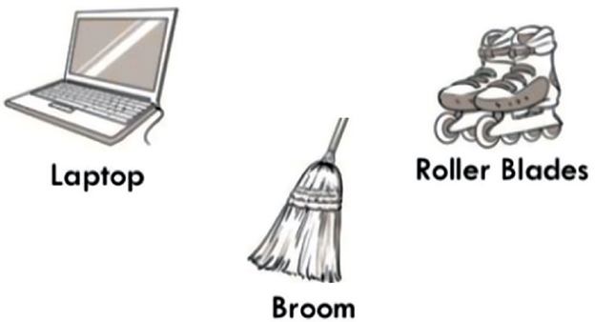

Everyday objects can be technology (Source: PLANETS)

Topographic map:
A representation of the shape of land in an area
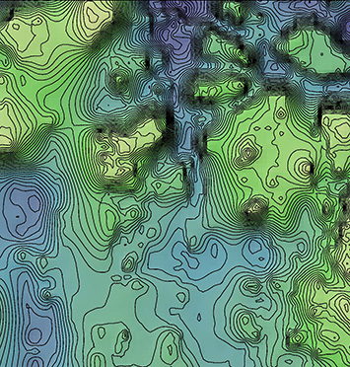
Topographic map of Iani Chaos landing site, Mars
(Source: NASA/JPL-MOLA)

Topography:
The shape of land in an area
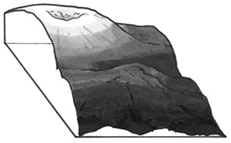
Cross-section of a mountain (Source: PLANETS)

