Title of the document. Text is:
Your PLANETS Translatable Glossary for:
Worlds Apart:
Remote Sensing of Mars

You can add drawings and notes under the words to help remember their meanings.

# 

## Composition:

What a surface is made of

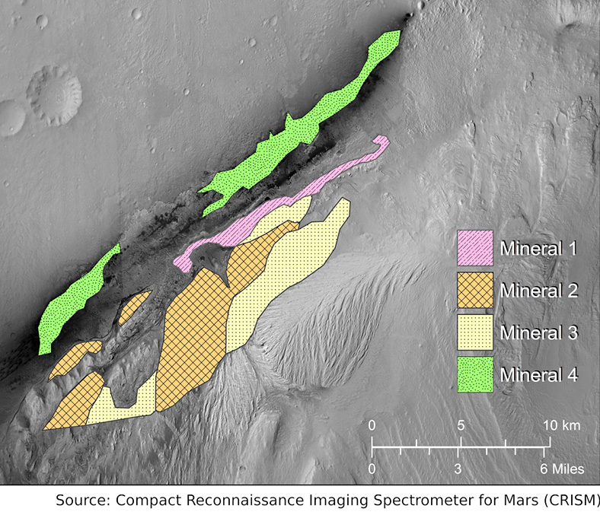

Mineral Map of Gale Crater Rim (Source: NASA CRISM & PLANETS)

## CTX:

Context Camera, a camera on the Mars Reconnaissance Orbiter

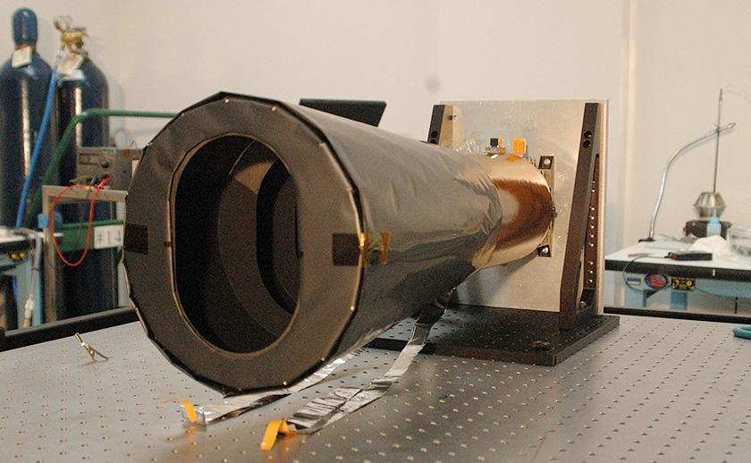

CTX being built (Credit: NASA/JPL-Caltech)

## Fairing:

The part that sits on top of the rocket and protects a spacecraft during launch



Cutout illustration of spacecraft fairing (Source: PLANETS)

## Habitable:

Can or once could have supported some form of life

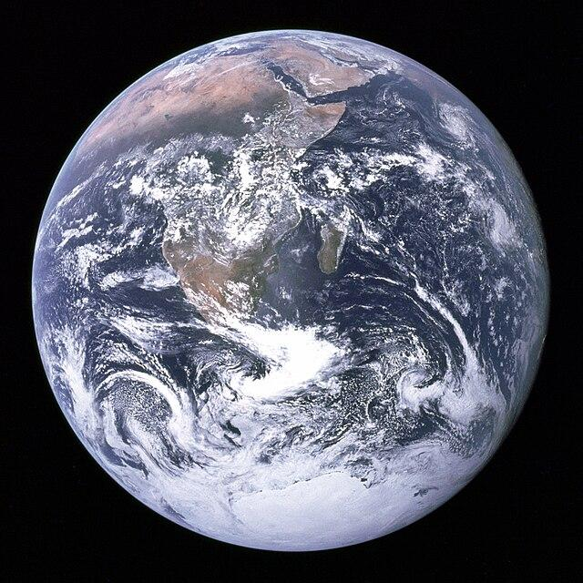

“The Blue Marble” Planet Earth (Source: NASA-Apollo 17)

## HiRISE:

High Resolution Imaging Science Experiment (HiRISE), a camera on the Mars Reconnaissance Orbiter (MRO)



HiRISE Camera on MRO (Source: NASA-MRO)

## Landform:

A shape on the surface of a planetary body

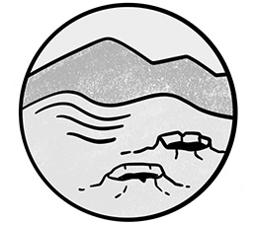

Craters, hills, and mountains are types of landforms (Source: PLANETS)

## LiDAR:

Light detection and ranging, a technique that uses lasers to measure distance

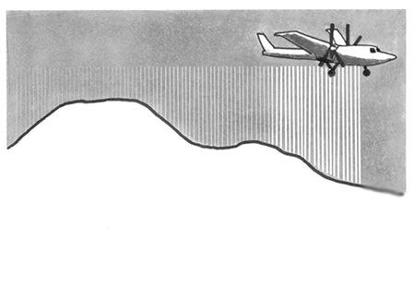

Illustration of airplane using LiDAR (Source: PLANETS)

## Physical properties:

The shape and texture of a surface

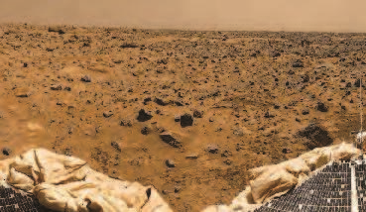

Surface of Mars (Image Credit: NASA/JPL- Pathfinder)

## Resolution:

The amount of detail in an image

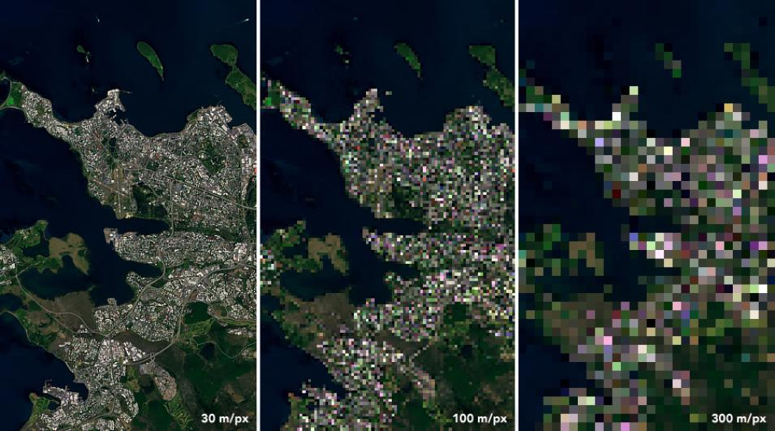

Landsat 8 image of Reykjavik, Iceland (Source: NASA Earth Observatory)

## Spectrometer:

A technology that measures the amount of light reflected from an object at many different colors (wavelengths).

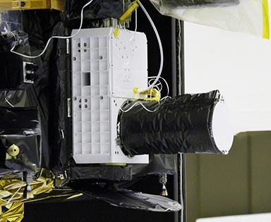

Spectrometer on Mars Reconnaissance Orbiter (MRO)   
(Source: NASA/JPL-Caltech/JHUAPL)

## Spectroscopy:

The study of how light of different colors behaves when it touches something

Spectral graph of "Olivine 1" showing light reflection percentages over visible and infrared wavelengths.

Transcribed Text:

Visible, Infrared, Violet, Blue, Green, Yellow, Orange, Red, Olivine 1, % of Light Reflected, Wavelength (microns), Higher Energy, Lower Energy.

Olivine Spectrum (Source: PLANETS)

## Spectrum:

A range of colors–the rainbow spectrum features a wide range of wavelengths

(Plural: spectra)



The spectrum of visible light (Source: PLANETS)

# 

## Topographic map:

A representation of the shape of land in an area

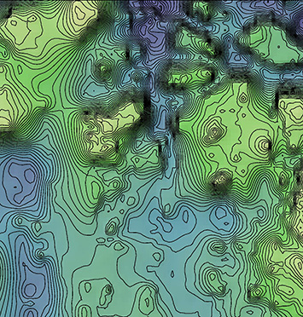

Topographic map of Iani Chaos landing site, Mars (Source: NASA/JPL-MOLA)

## Topography:

The shape of land in an area

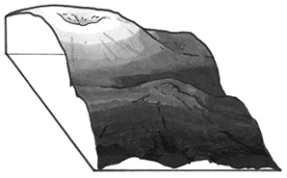

Cross-section of a mountain (Source: PLANETS)