
You can add drawings and notes under the words to help remember their meanings.

Composition:
What a surface is made of
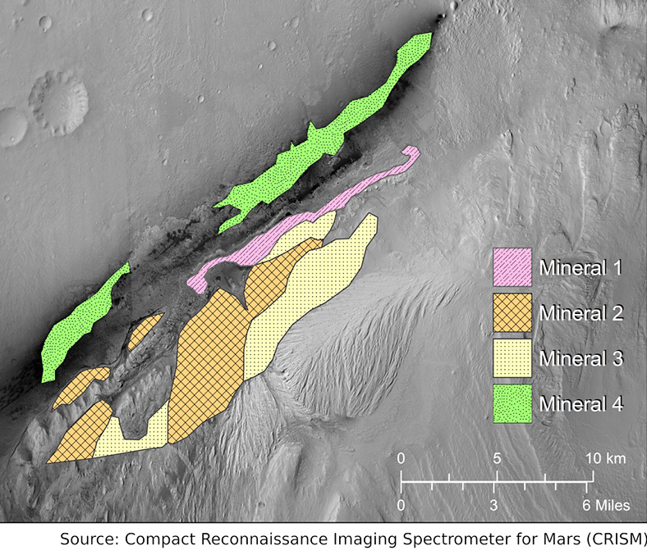
Mineral Map of Gale Crater Rim (Source: NASA CRISM & PLANETS)

CTX:
Context Camera, a camera on the Mars Reconnaissance Orbiter
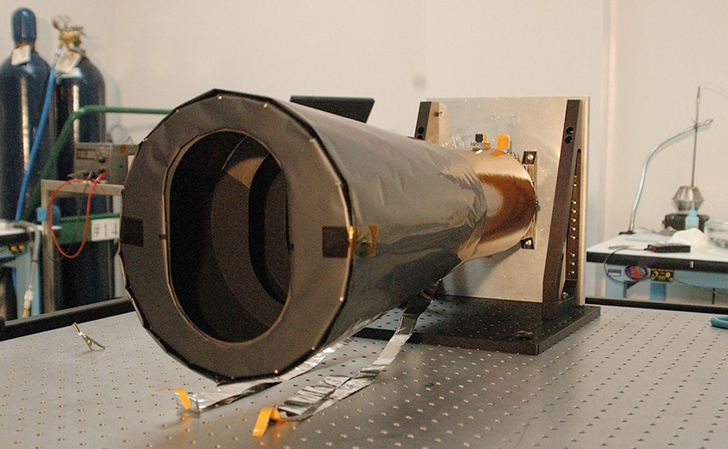
CTX being built (Credit: NASA/JPL-Caltech)

Fairing:
The part that sits on top of the rocket and protects a spacecraft during launch

Cutout illustration of spacecraft fairing (Source: PLANETS)

Habitable:
Can or once could have supported some form of life
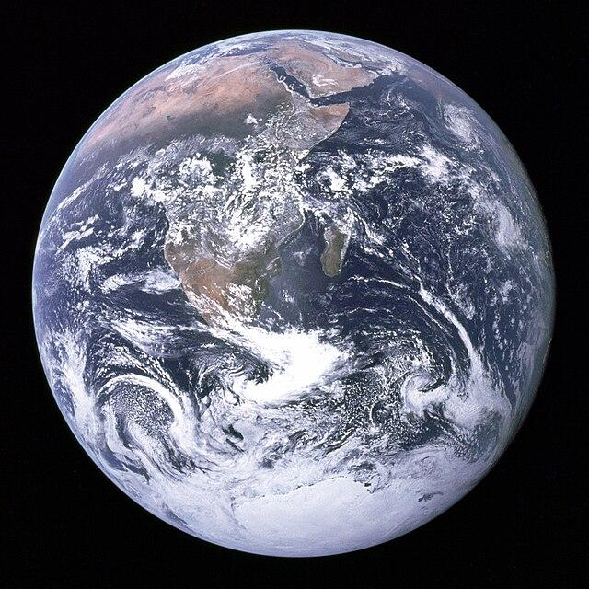
“The Blue Marble” Planet Earth (Source: NASA-Apollo 17)

HiRISE:
High Resolution Imaging Science Experiment (HiRISE), a camera on the Mars Reconnaissance Orbiter (MRO)
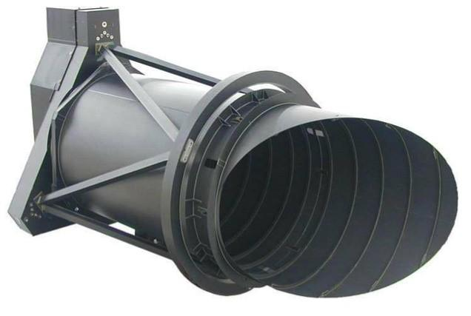
HiRISE Camera on MRO (Source: NASA-MRO)

Landform:
A shape on the surface of a planetary body
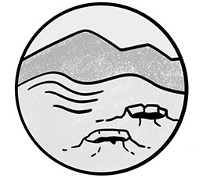
Craters, hills, and mountains are types of landforms (Source: PLANETS)

LiDAR:
Light detection and ranging, a technique that uses lasers to measure distance
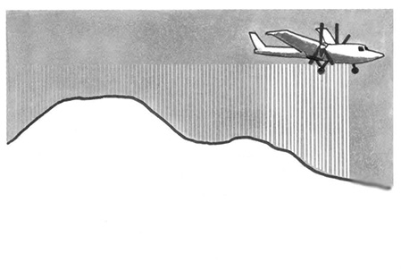
Illustration of airplane using LiDAR (Source: PLANETS)

Physical properties:
The shape and texture of a surface
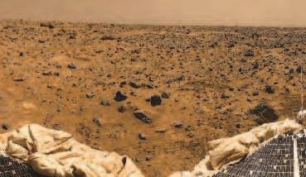
Surface of Mars (Image Credit: NASA/JPL- Pathfinder)

Resolution:
The amount of detail in an image
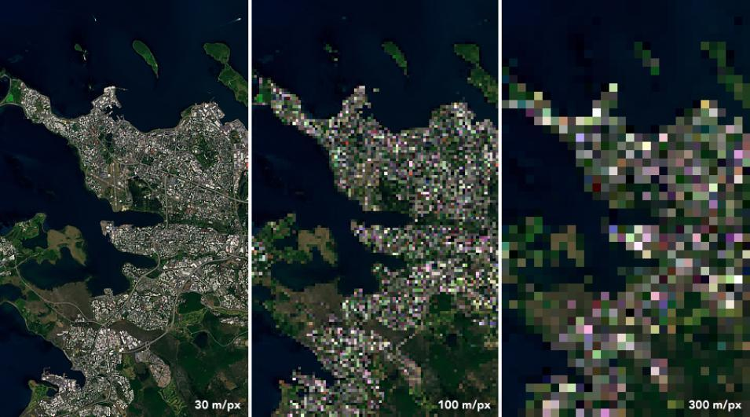
Landsat 8 image of Reykjavik, Iceland (Source: NASA Earth Observatory)

Spectrometer:
A technology that measures the amount of light reflected from an object at many different colors (wavelengths).
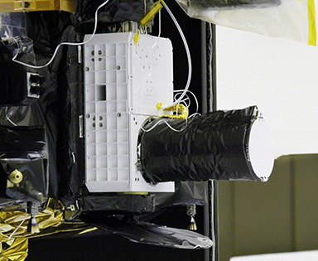
Spectrometer on Mars Reconnaissance Orbiter (MRO)
(Source: NASA/JPL-Caltech/JHUAPL)

Spectroscopy:
The study of how light of different colors behaves when it touches something
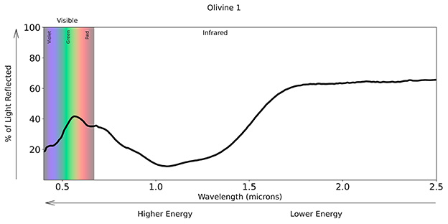
Olivine Spectrum (Source: PLANETS)

Spectrum:
A range of colors–the rainbow spectrum features a wide range of wavelengths
(Plural: spectra)

The spectrum of visible light (Source: PLANETS)

Topographic map:
A representation of the shape of land in an area
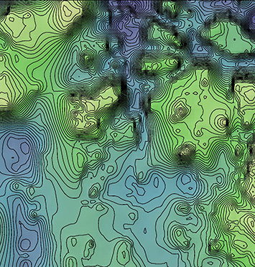
Topographic map of Iani Chaos landing site, Mars (Source: NASA/JPL-MOLA)

Topography:
The shape of land in an area
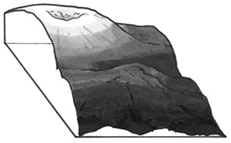
Cross-section of a mountain (Source: PLANETS)

