Title of the document. Text is:
Your PLANETS Translatable Glossary for:
Space Hazards: Engineering Translatable Glossary 

Educators, in order to scaffold learners’ language development during these activities, please use this editable file as needed to support students’ language captured on the Our Ideas poster and in their student notebook.

To support their language development, you can include translations and/or images that your learners will relate to. If you are fluent in your learner’s languages, you can write the translations yourself. If you are not, consider asking a family or community member to help you. There also may be online dictionaries for your learner’s languages like these for [American Sign Language](https://atomichands.com/asl-stem-dictionaries/) or this for [Navajo](https://enablenavajo.org/dine/).

Remember that vocabulary is not intended to be “front-loaded” for learners, but rather it develops as they engage in the activities. To support this development, be sure to leave room for learners to add their own drawings and notes under the words to help them articulate and remember their meanings.

# Hazard:

A danger or something that can cause harm.

## Translation:

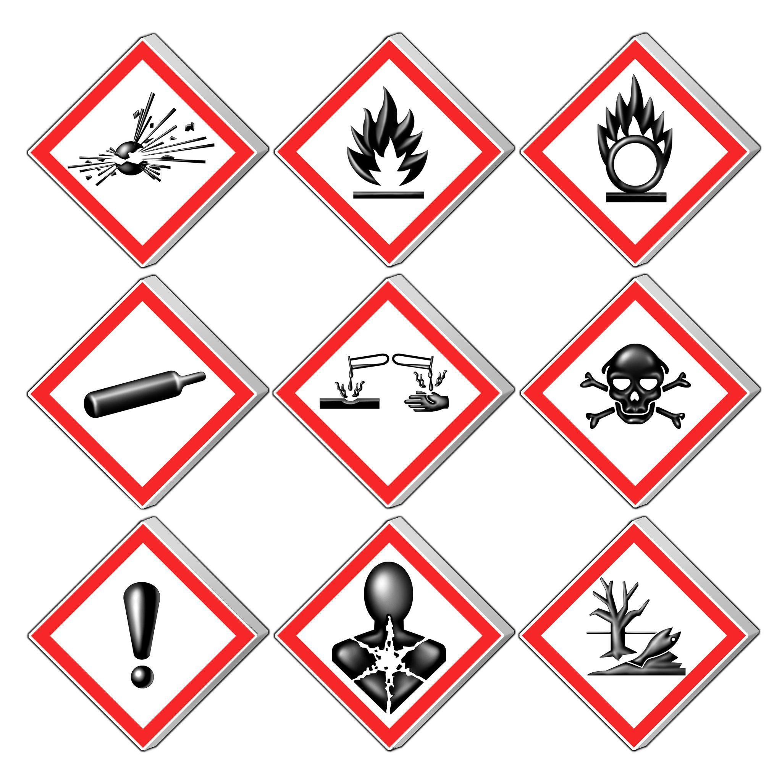

Source: Wikimedia Commons

# 

# 

# 

# 

# Mitigation:

Actions taken to reduce or prevent harm or damage.

## Translation:



Source: Wikimedia Commons

# 

# Space Junk:

Broken pieces of old satellites, rockets, or other objects left in space.

## Translation:

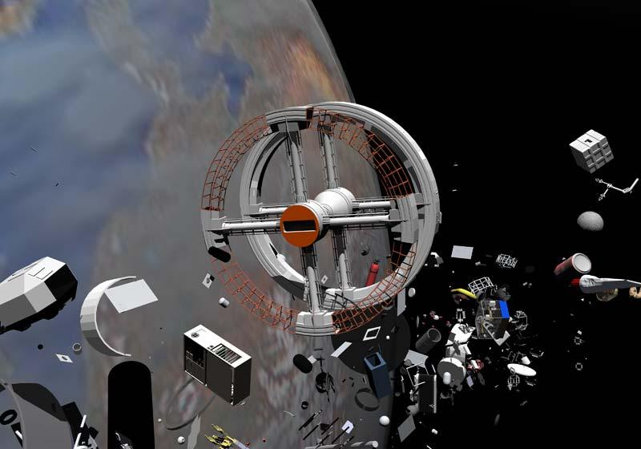

Source: Wikimedia Commons

# Mission Patch:

A special design worn by astronauts to represent the mission, crew, and goals of their space journey.

## Translation:

**The image shows a circular embroidered patch with a distinct design. The central element is a large golden star set against a dark blue background. Surrounding the star, four smaller white stars are positioned. In the foreground, a muscular gorilla stands upright, holding a trident and an American flag in its right arm, and a tree branch in its left arm. To the gorilla's right, a white bird with spread wings is in mid-flight. The patch's border is red with white text, forming a complete circle around the central imagery.

Transcribed Text:

"National Reconnaissance Office NROL-16 Titan IVB-30 To Success"**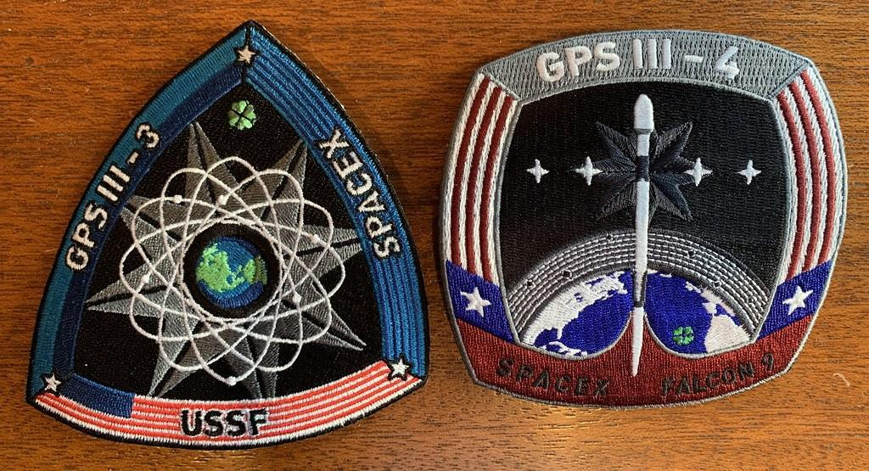

Source: Flickr

# Space Glove:

A protective glove worn by astronauts to keep their hands safe in space.

## Translation:

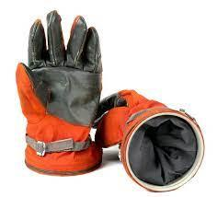

Source: Bonhams

# Space Suit:

A special suit astronauts wear to protect their body, provide air, and keep them safe in space.

## Translation:

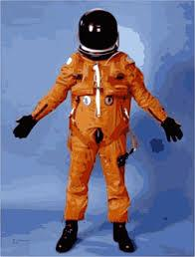

Source: Openclipart

# Spacecraft:

A vehicle designed to travel in space, like a spaceship or space shuttle.

## Translation:

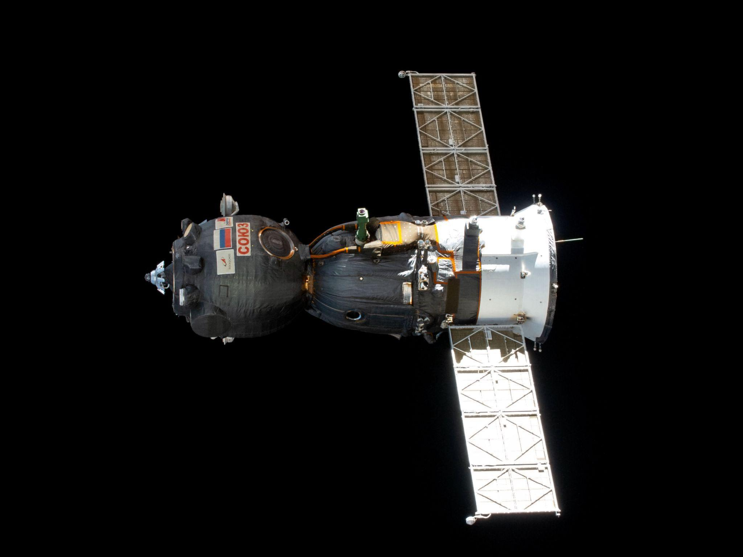

Source: Wikimedia Commons

# Impact Test:

A test to see how something reacts when it gets hit or crashes into something

## Translation:

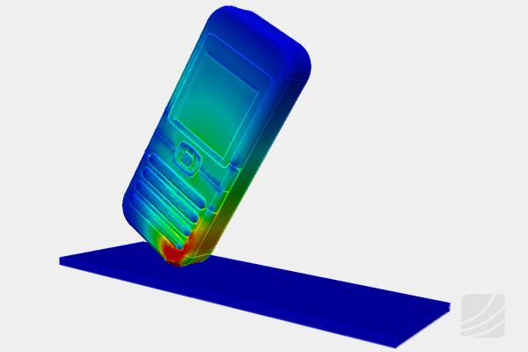

Source: Wikimedia Commons