
Educators, in order to scaffold learners’ language development during these activities, please use this editable file as needed to support students’ language captured on the Our Ideas poster and in their student notebook.
To support their language development, you can include translations and/or images that your learners will relate to. If you are fluent in your learner’s languages, you can write the translations yourself. If you are not, consider asking a family or community member to help you. There also may be online dictionaries for your learner’s languages like these for American Sign Language or this for Navajo.
Remember that vocabulary is not intended to be “front-loaded” for learners, but rather it develops as they engage in the activities. To support this development, be sure to leave room for learners to add their own drawings and notes under the words to help them articulate and remember their meanings.

Hazard:
A danger or something that can cause harm.

Translation:
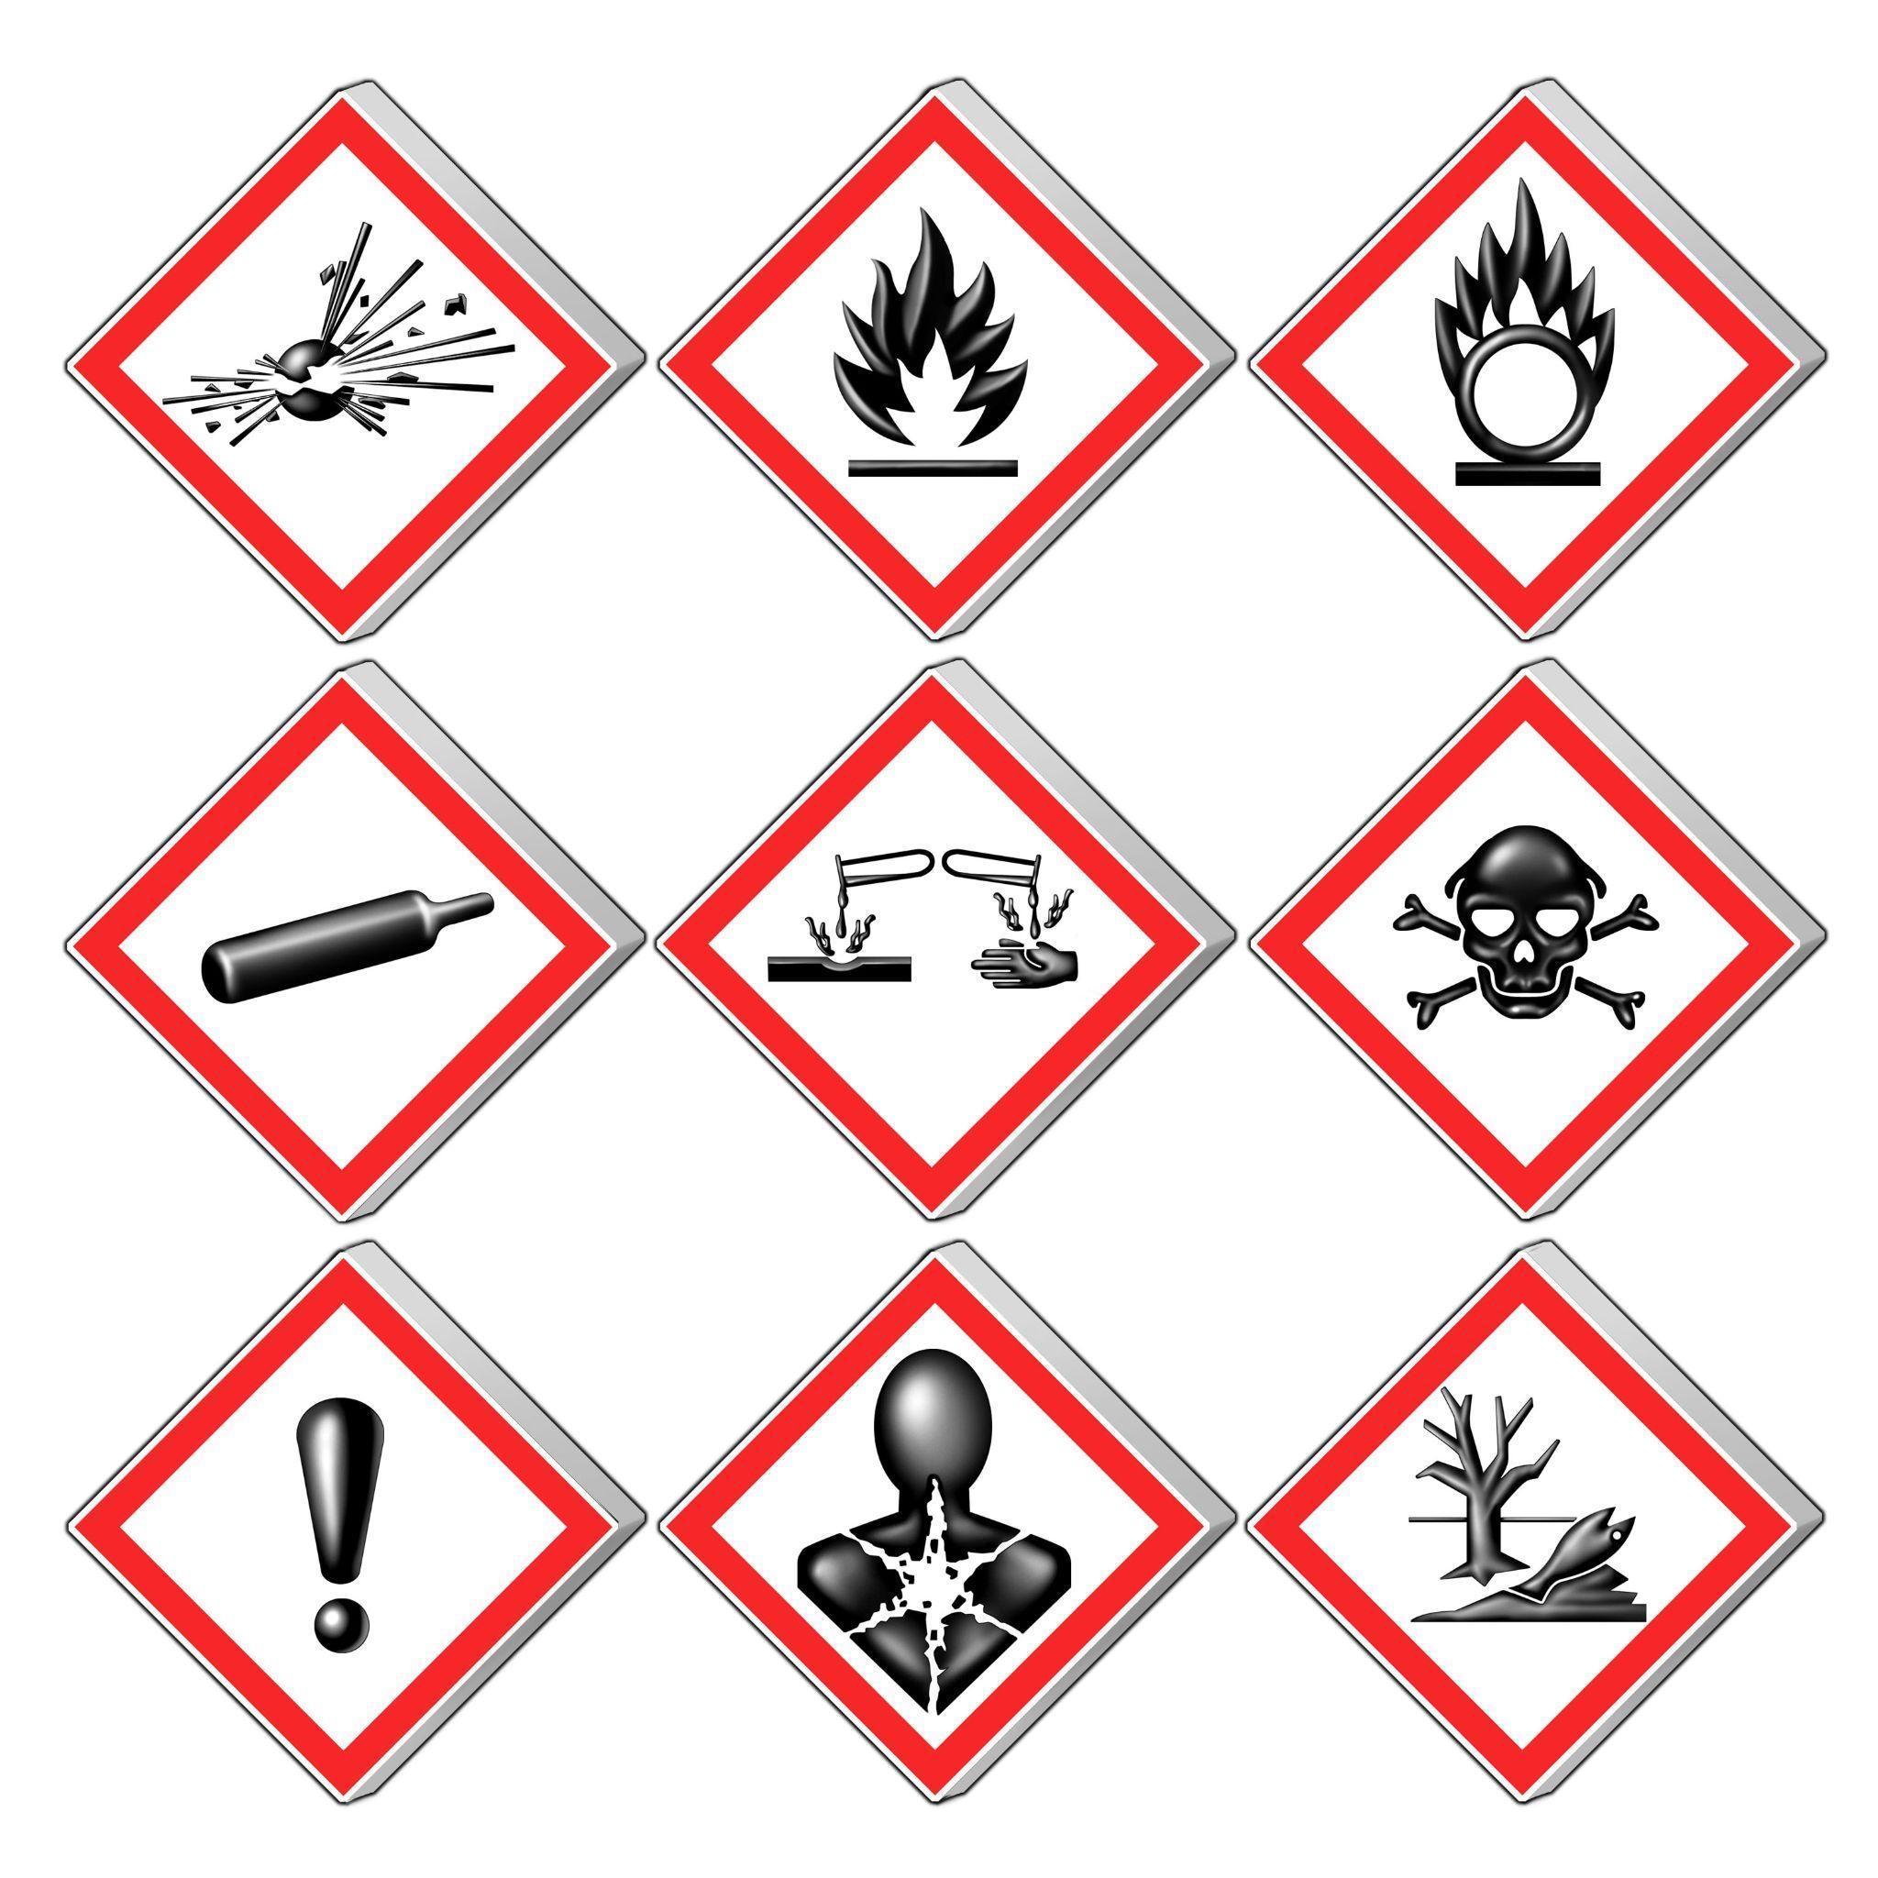
Source: Wikimedia Commons

Mitigation:
Actions taken to reduce or prevent harm or damage.

Translation:
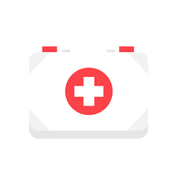
Source: Wikimedia Commons

Space Junk:
Broken pieces of old satellites, rockets, or other objects left in space.

Translation:
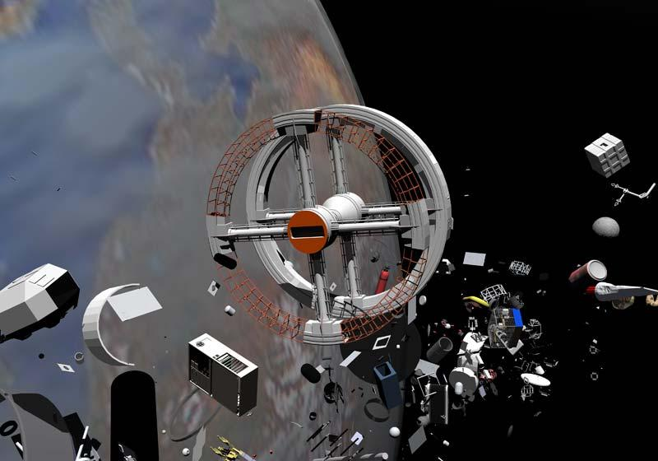
Source: Wikimedia Commons

Mission Patch:
A special design worn by astronauts to represent the mission, crew, and goals of their space journey.

Translation:

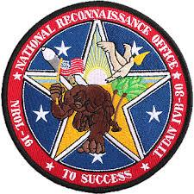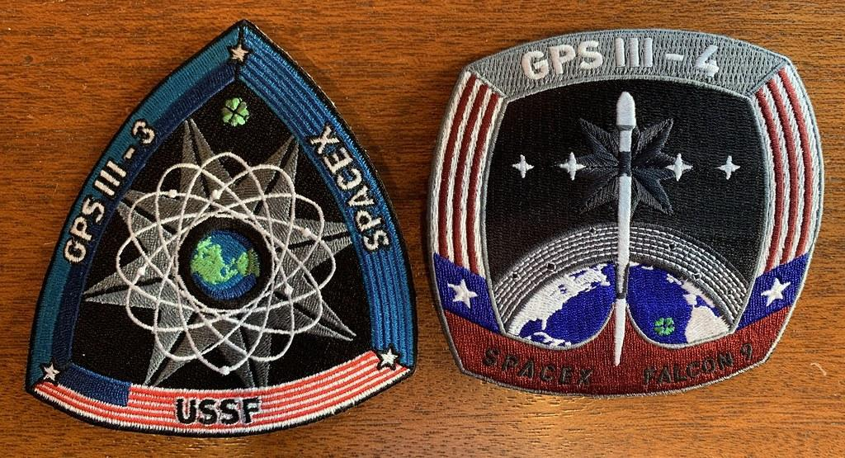
Source: Flickr

Space Glove:
A protective glove worn by astronauts to keep their hands safe in space.

Translation:
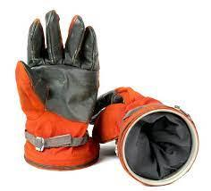
Source: Bonhams

Space Suit:
A special suit astronauts wear to protect their body, provide air, and keep them safe in space.

Translation:
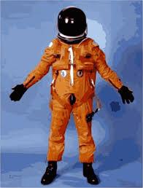
Source: Openclipart

Spacecraft:
A vehicle designed to travel in space, like a spaceship or space shuttle.

Translation:
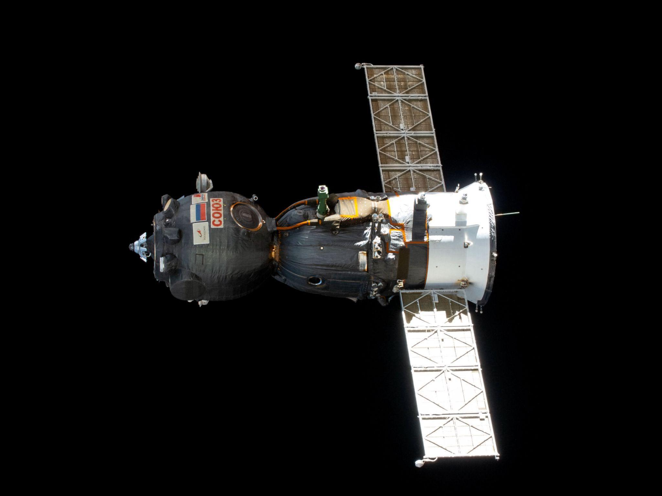
Source: Wikimedia Commons

Impact Test:
A test to see how something reacts when it gets hit or crashes into something

Translation:
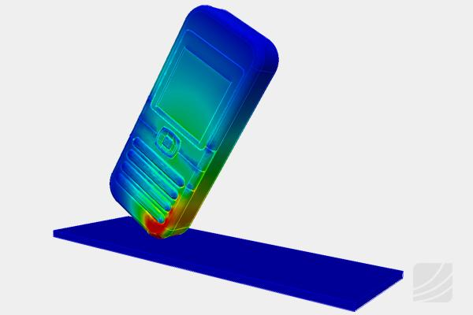
Source: Wikimedia Commons

