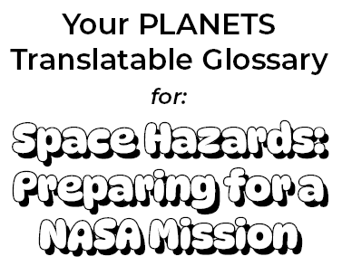
Educators, in order to scaffold learners’ language development during these activities, please use this editable file as needed to support students’ language captured on the Our Ideas poster and in their student notebook.
To support their language development, you can include translations and/or images that your learners will relate to. If you are fluent in your learner’s languages, you can write the translations yourself. If you are not, consider asking a family or community member to help you. There also may be online dictionaries for your learner’s languages like these for American Sign Language or this for Navajo.
Remember that vocabulary is not intended to be “front-loaded” for learners, but rather it develops as they engage in the activities. To support this development, be sure to leave room for learners to add their own drawings and notes under the words to help them articulate and remember their meanings.

Hazard:
A danger or something that can cause harm.

Translation:
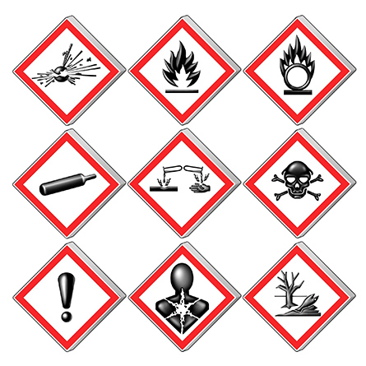
Source: Wikimedia Commons

Mitigation:
Actions taken to reduce or prevent harm or damage.

Translation:

Source: Wikimedia Commons

Dust Storm:
A strong wind that blows dirt across the land, often making it hard to see.

Translation:
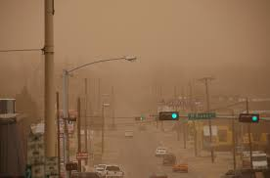
Source: Flickr

Flood:
An overflow of water that covers the land and causes damage.

Translation:
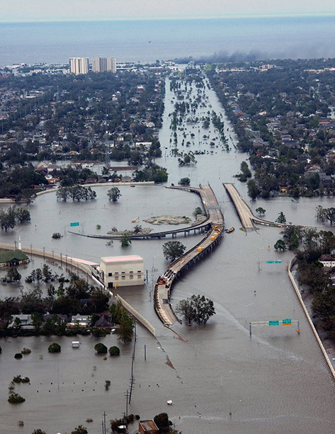
Source: Wikimedia Commons

Meteor Impact:
A crash of a meteor into the Earth’s surface.

Translation:
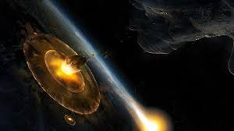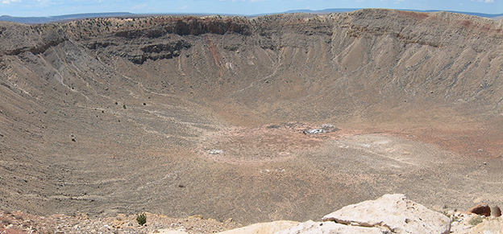
Source: Wikimedia Commons

Meteor:
A small rock or piece of space debris.

Translation:
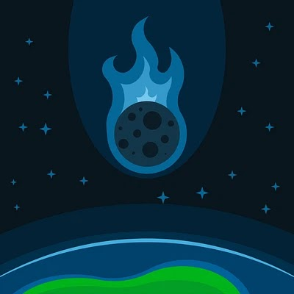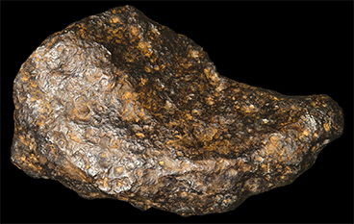
Source: Openclipart/Wikimedia Commons

Asteroid:
A large rock in space, often orbiting the Sun.

Translation:
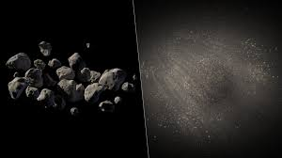
Source: Wikimedia Commons

Volcano:
A mountain that can erupt with hot, melted rock, ash, and gases from deep inside the Earth.

Translation:
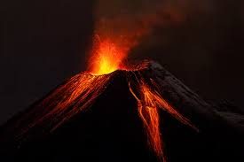
Source: Wikimedia Commons

Lava Flow:
Hot, melted rock from a volcano that flows down the sides during an eruption.

Translation:
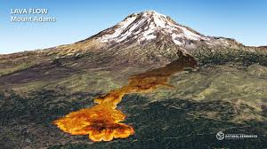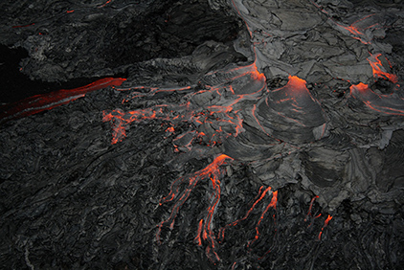
Source: Wikimedia Commons

Low Gravity:
A weaker force pulling things toward a planet or moon.

Translation:
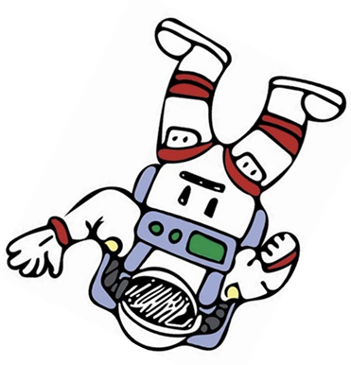
Source: Openclipart

Poison Soil:
Soil that has harmful chemicals or substances in it, making it unsafe for plants or animals.

Translation:
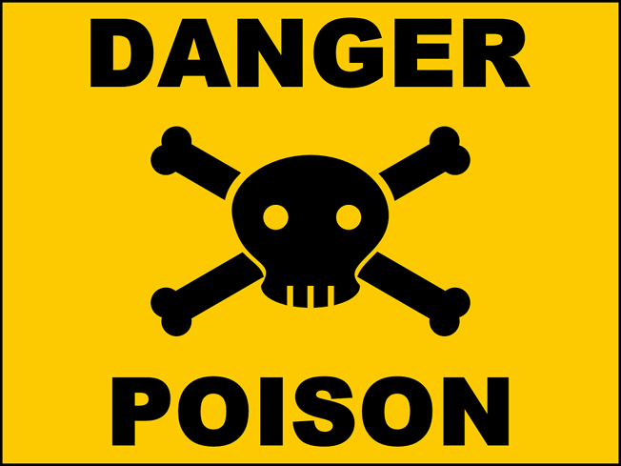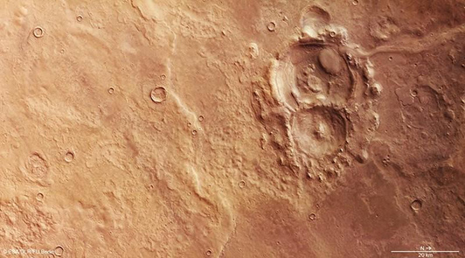
Source: Flickr

Space Radiation:
Dangerous energy from the Sun or other stars in space that can harm living things.

Translation:
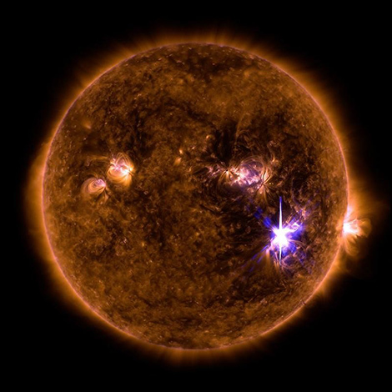
Source: Flickr

Dangerous Dust:
Small particles in the air that can be harmful to breathe or cause damage.

Translation:
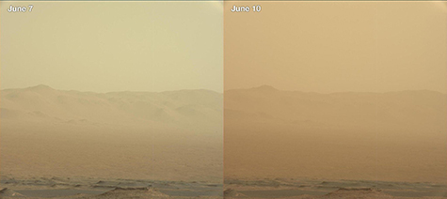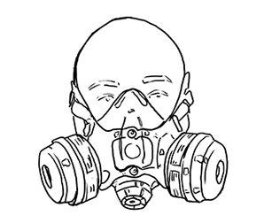
Source: Flickr

