Title of the document. Text is:
Your PLANETS Translatable Glossary for:
Water in Extreme Environments: Engineering a Water Reuse Process

# 

# Clarity:

How clear water is

## Translation:

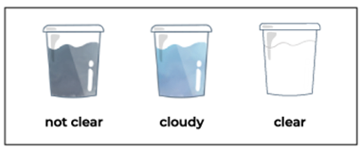

# 

# Clean water:

Water that is safe enough to drink and wash with

## Translation:

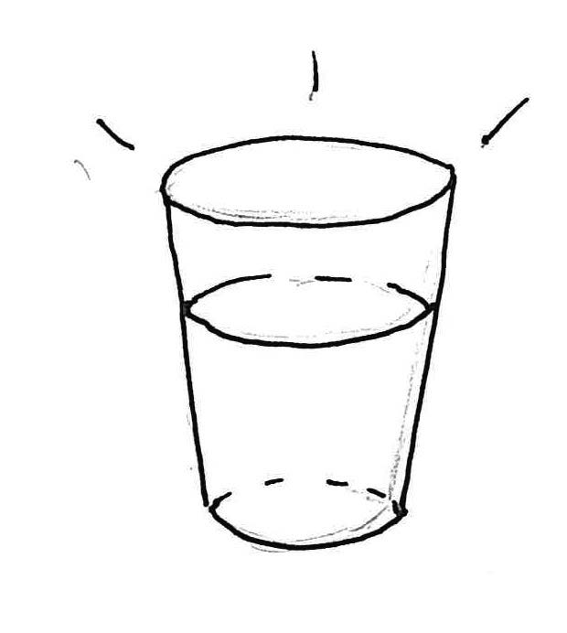

# 

# Constraints:

Limits on a design

## Translation:

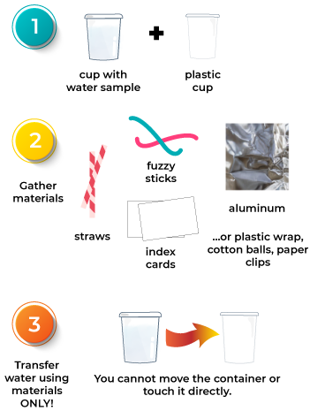

# 

# Contaminant:

A substance that makes water dirty or unsafe to drink

## Translation:

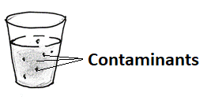

# Criteria:

Things your design needs to do

## Translation:

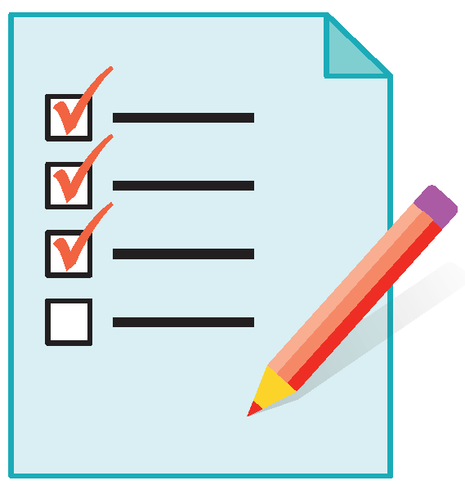

# 

# Engineering Design Process:

A set of phases that engineers use to design technologies to solve a problem

## Translation:

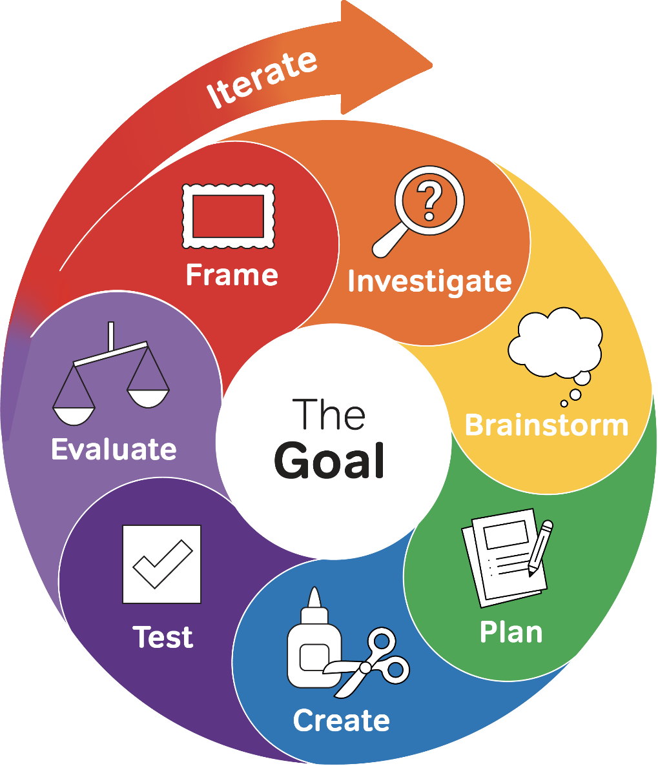

# 

# Filter:

A technology that removes some kinds of contaminants from water

## Translation:

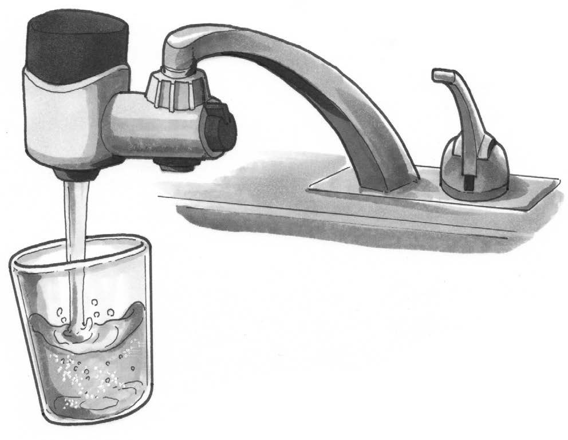

# 

# pH:

How acidic or basic a sample is; pH strips are tools that measure pH

## Translation:

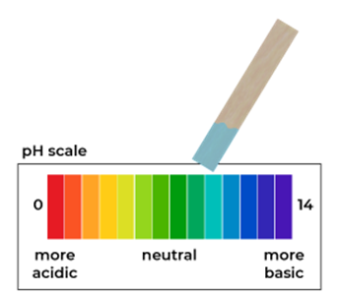

# 

# Process:

A series of actions or steps leading to a result or goal

## Translation:

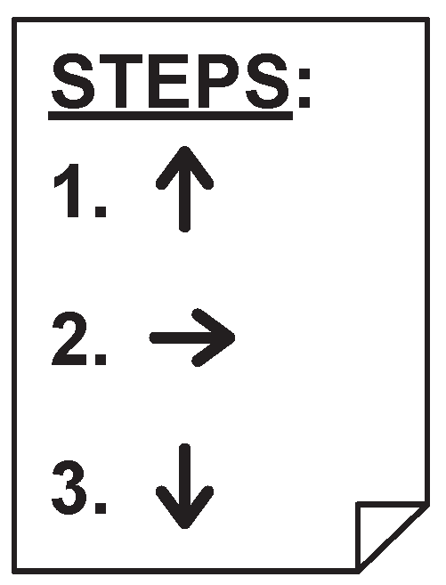

# 

# Somewhat contaminated water:

Water that has been used at least once and can be used again

## Translation:

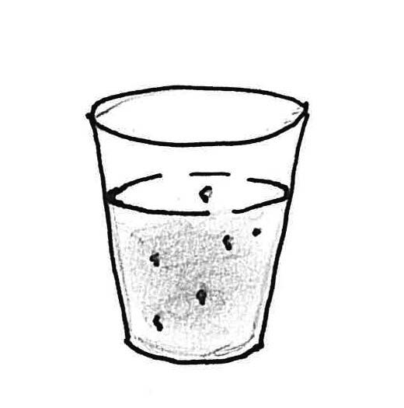

# 

# Technology:

Any object, system, or process designed by people to solve a problem

## Translation:

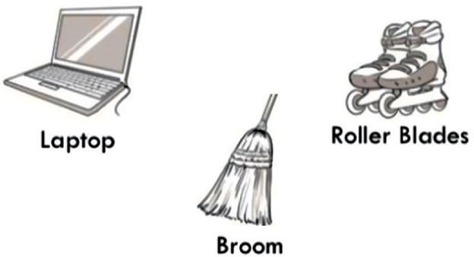

# Very contaminated water:

Water that is too dirty to be used again

## Translation:

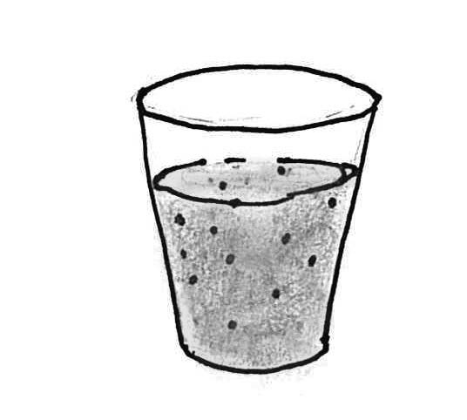

# 

# Water quality:

The characteristics that let us know if water is safe to use

## Translation:

