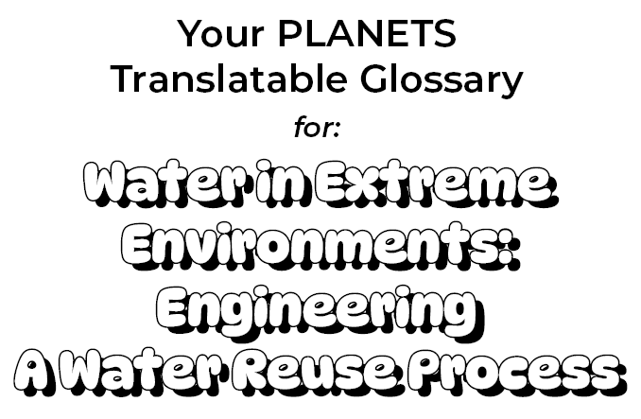

Clarity:
How clear water is

Translation:

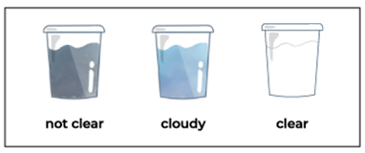

Clean water:
Water that is safe enough to drink and wash with

Translation:

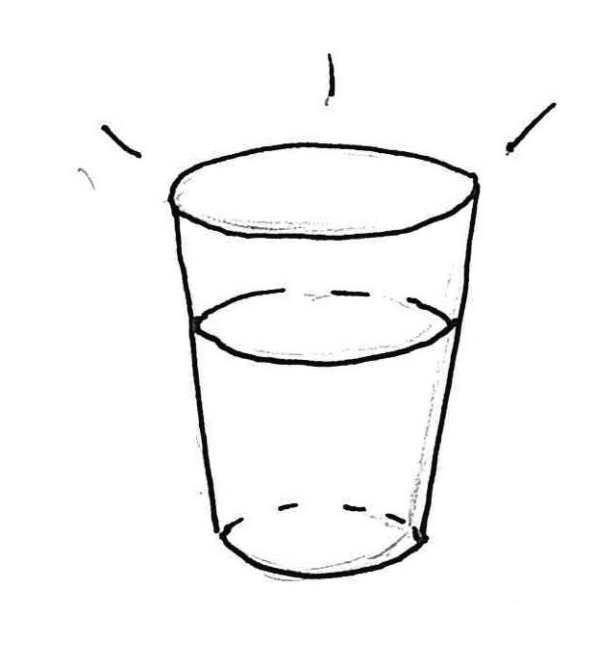

Constraints:
Limits on a design

Translation:

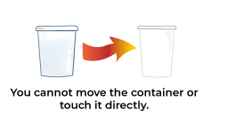

Contaminant:
A substance that makes water dirty or unsafe to drink

Translation:

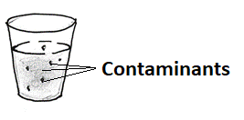

Criteria:
Things your design needs to do

Translation:

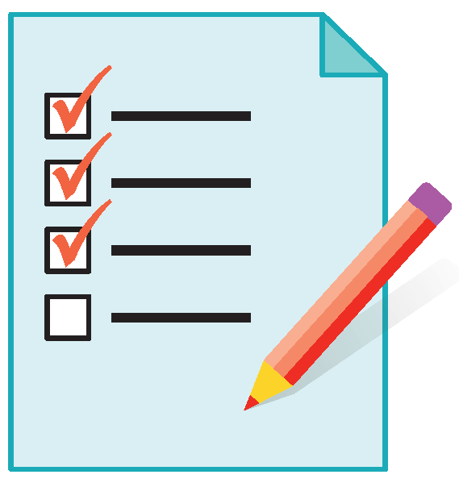

Engineering Design Process:
A set of phases that engineers use to design technologies to solve a problem

Translation:

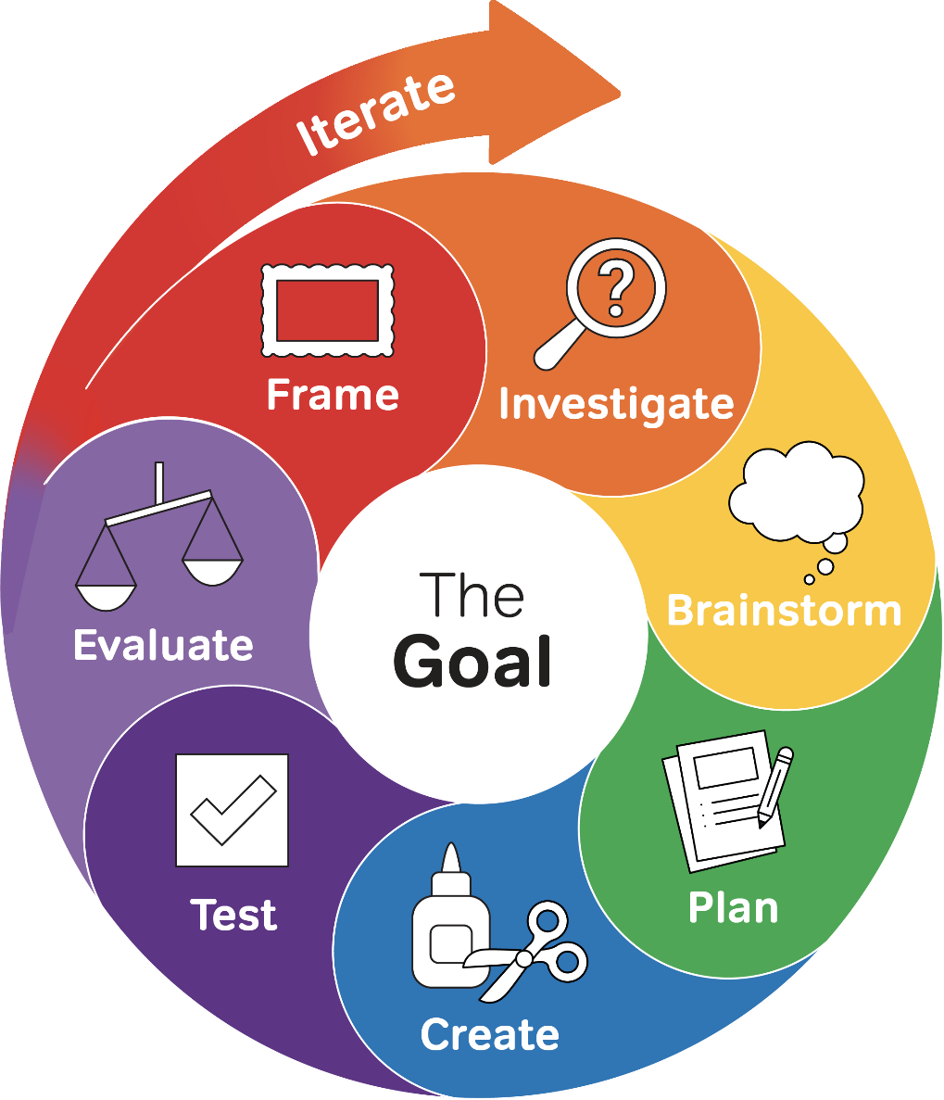

Filter:
A technology that removes some kinds of contaminants from water

Translation:

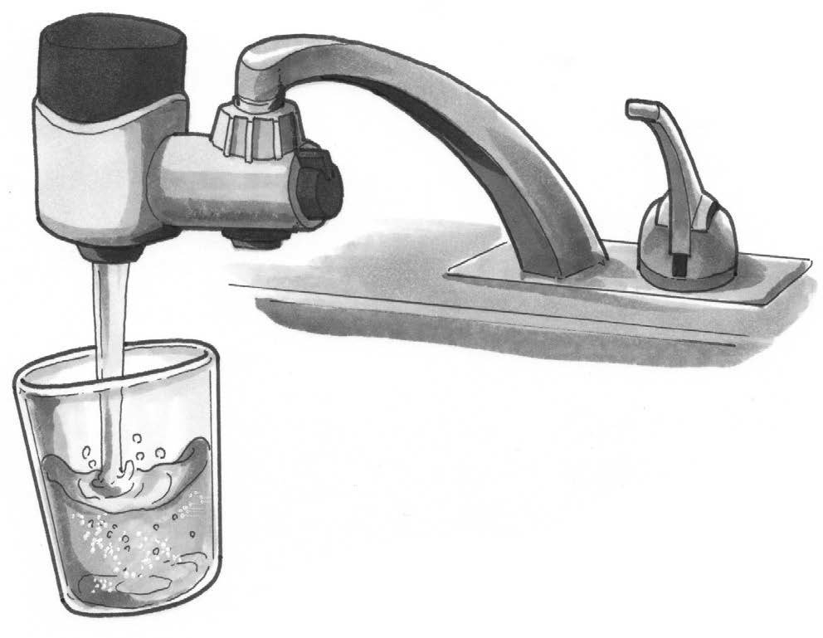

pH:
How acidic or basic a sample is; pH strips are tools that measure pH

Translation:

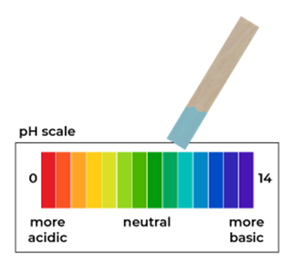

Process:
A series of actions or steps leading to a result or goal

Translation:

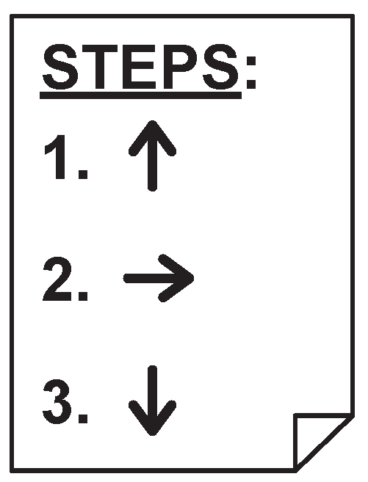

Somewhat contaminated water:
Water that has been used at least once and can be used again

Translation:

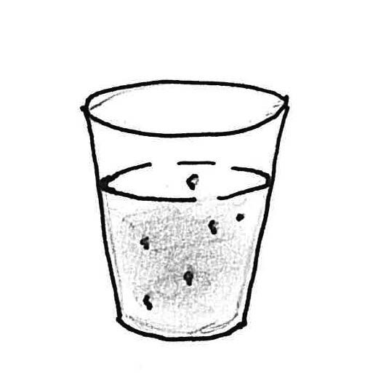

Technology:
Any object, system, or process designed by people to solve a problem

Translation:

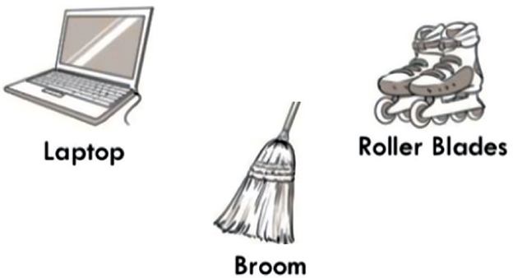

Very contaminated water:
Water that is too dirty to be used again

Translation:

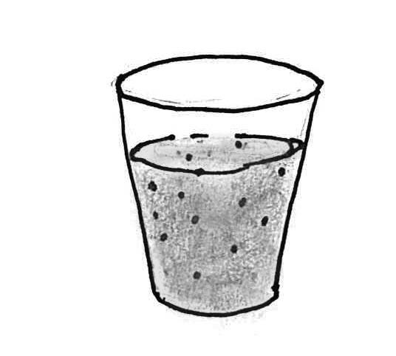

Water quality:
The characteristics that let us know if water is safe to use

Translation:

