Title of the document. Text is:
Your PLANETS Translatable Glossary for:
Water in Extreme Environments: Water in the Solar System

# 

# Atmosphere:

The air around a planet

## Translation:

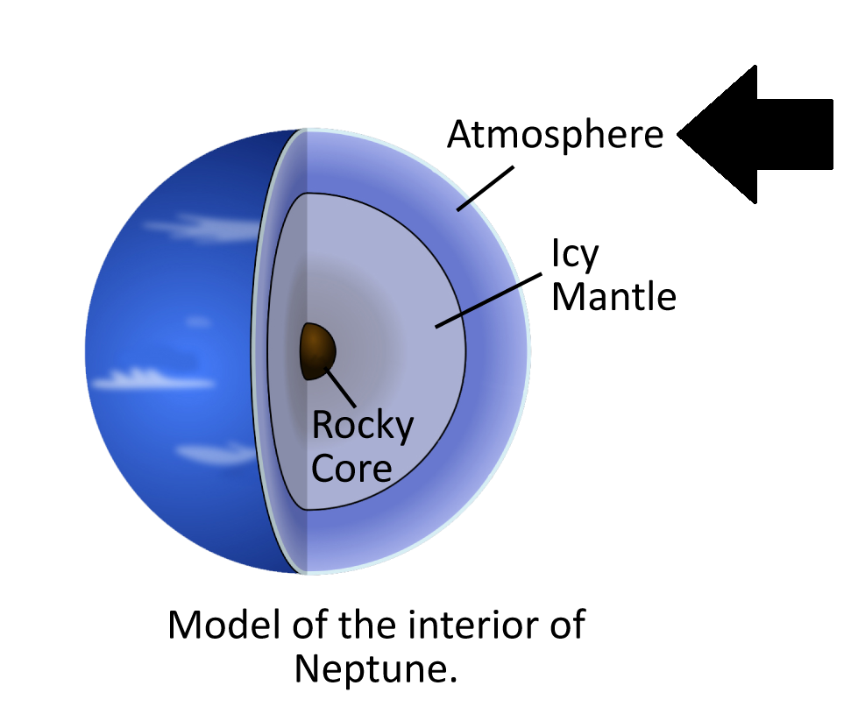

# Extremophile:

A living thing that lives in conditions that are extreme compared to the conditions that favor most life forms

## Translation:

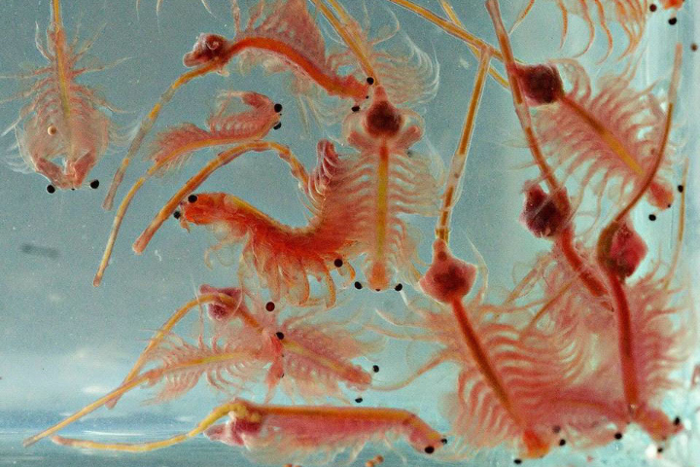

# Habitable:

Able to support life

## Translation:

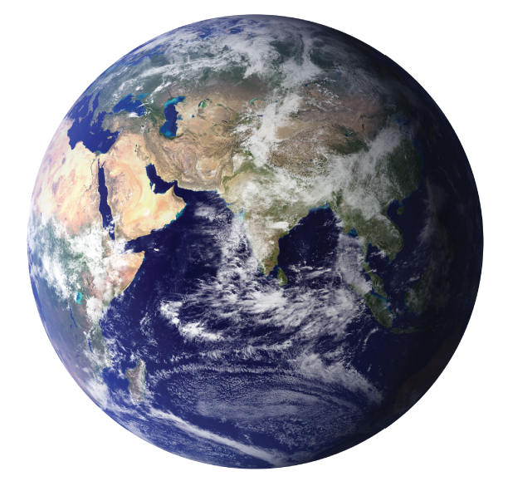

# Kuiper Belt:

A donut-shaped region of icy bodies beyond the orbit of Neptune

## Translation:

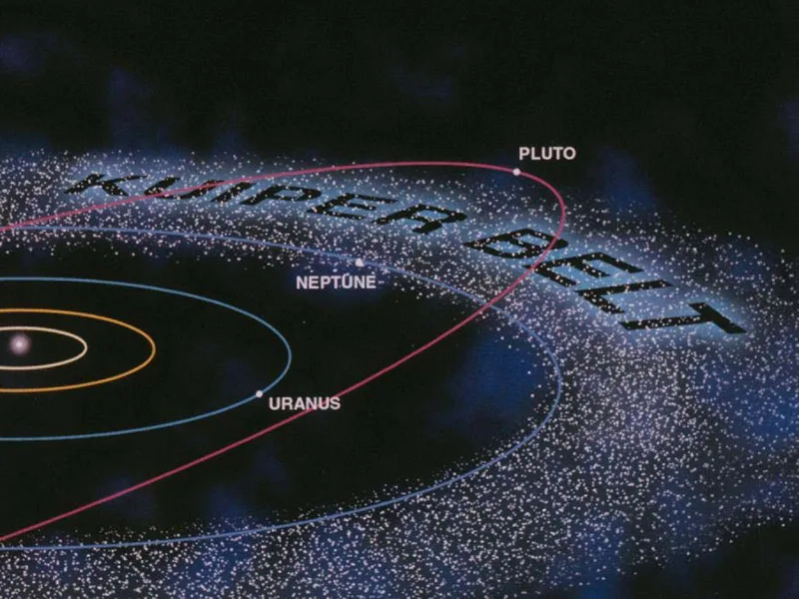

# Main Asteroid Belt:

A region in the solar system located roughly between the orbits of Mars and Jupiter that is occupied by numerous irregularly shaped bodies called *asteroids* or *minor planets*

## Translation:

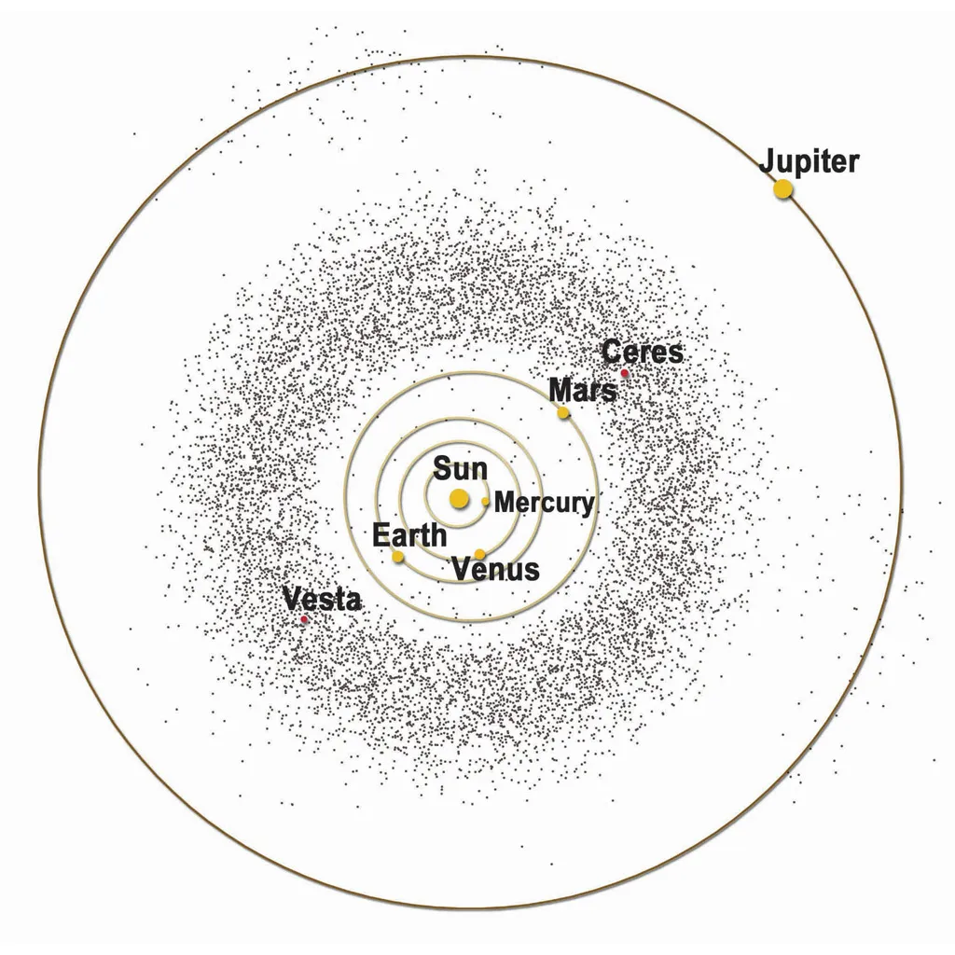

# Reservoir:

A place where water is stored

## Translation:

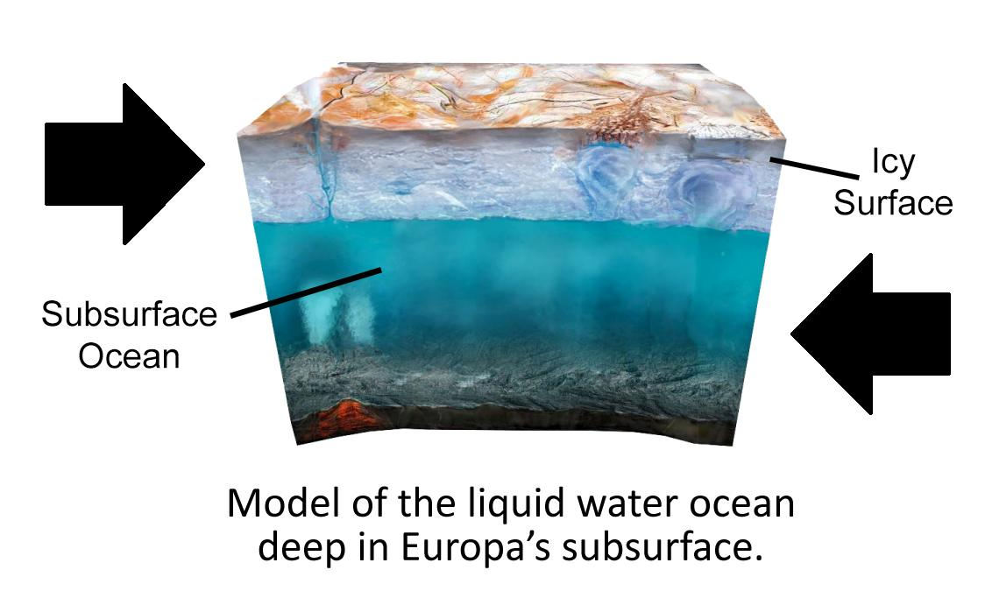

# Salinity:

The concentration of salt dissolved in water

## Translation:

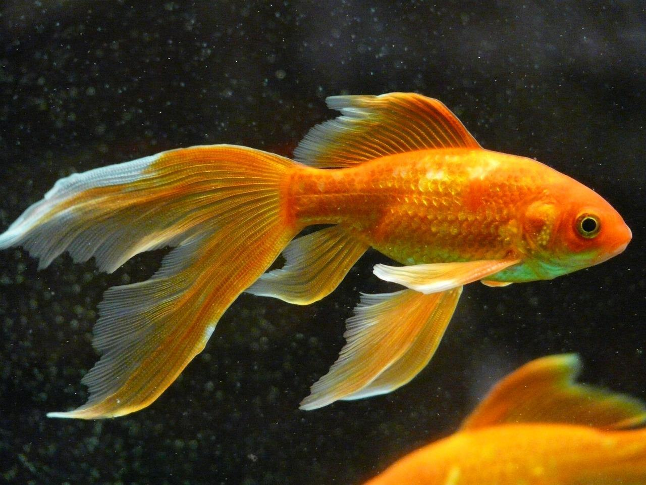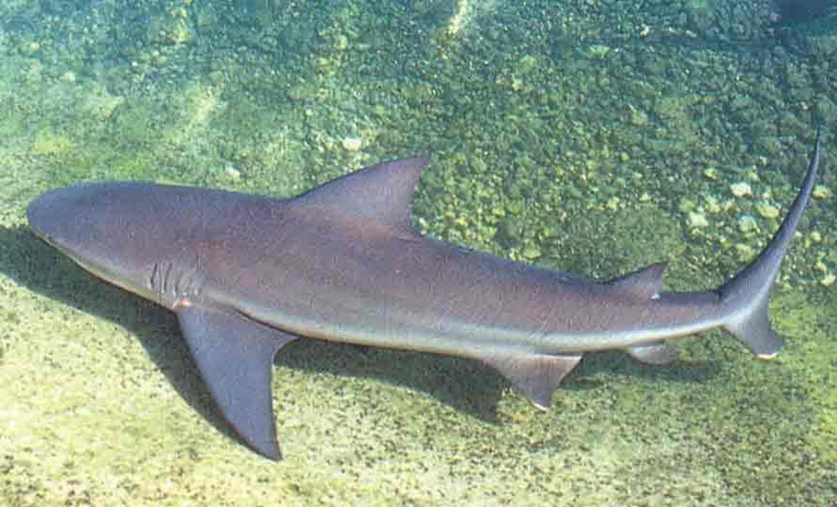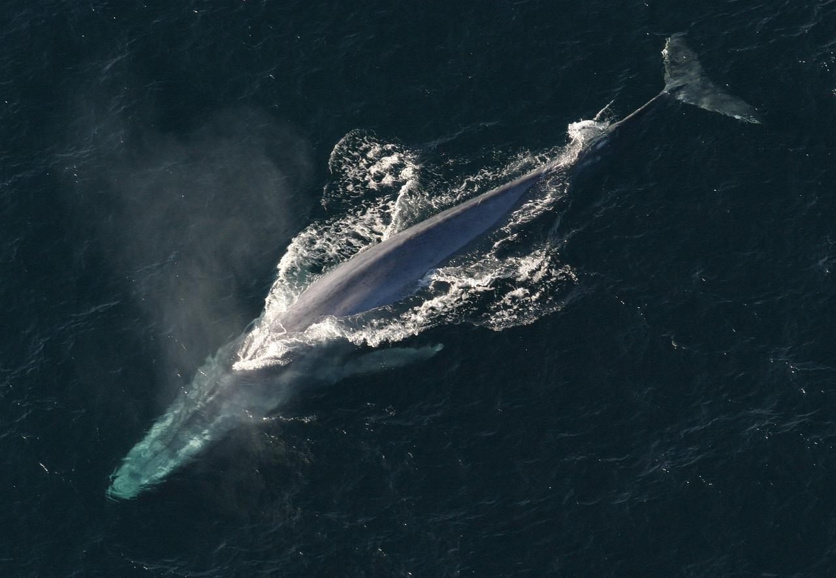

# Subsurface:

Places under the surface of a planet

## Translation:

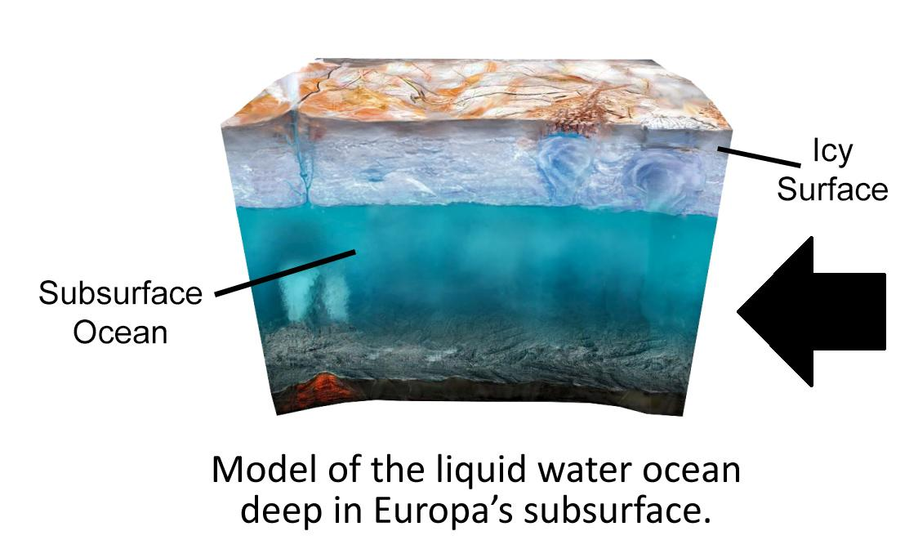

# Surface:

The part of a planet exposed to the atmosphere or space

## Translation:

