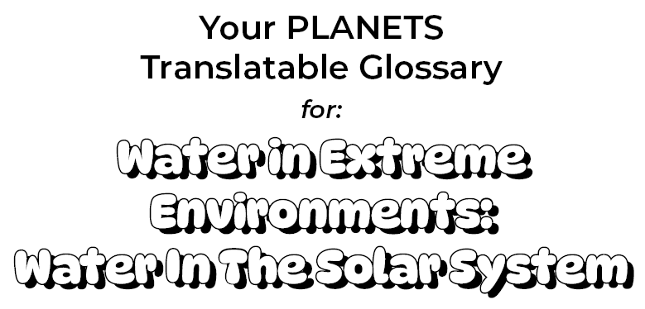

Atmosphere:
The air around a planet

Translation:

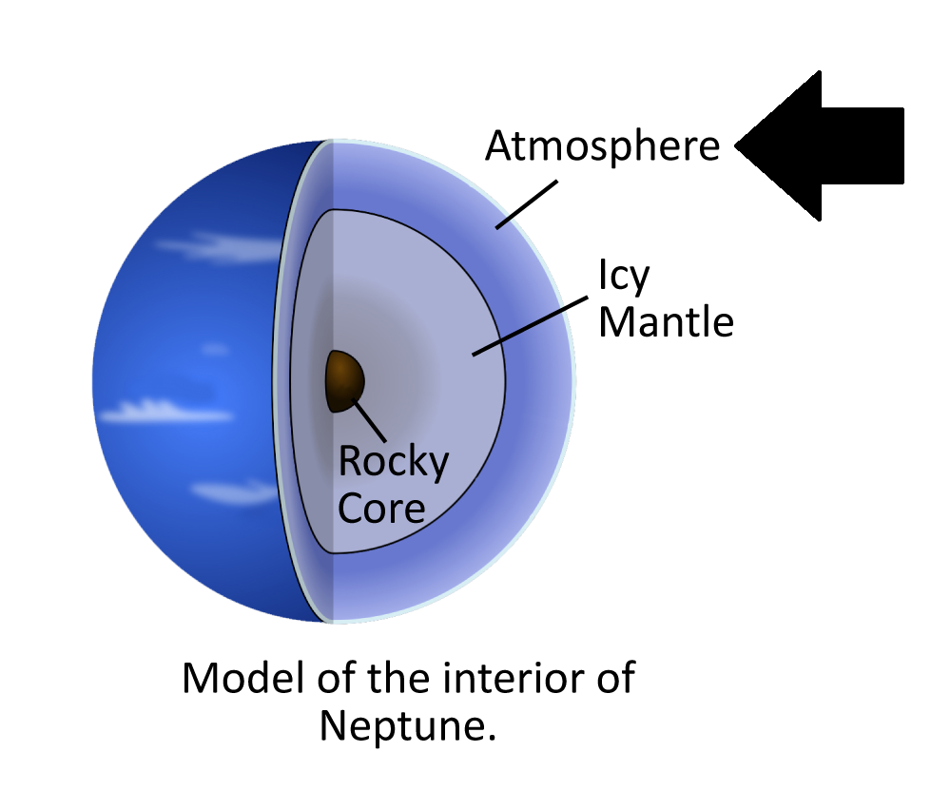

Extremophile:
A living thing that lives in conditions that are extreme compared to the conditions that favor most life forms

Translation:

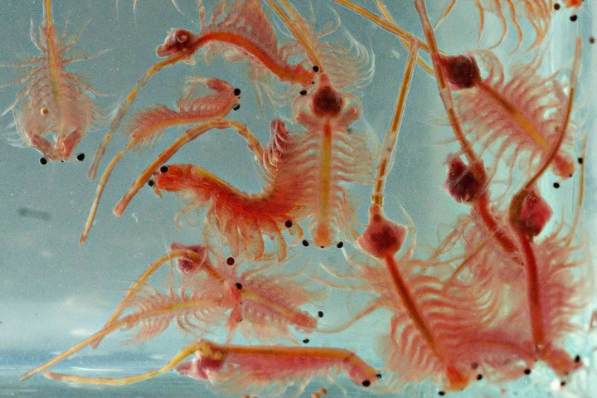

Habitable:
Able to support life

Translation:

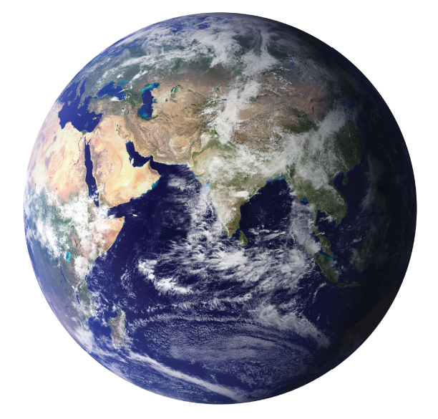

Kuiper Belt:
A donut-shaped region of icy bodies beyond the orbit of Neptune

Translation:

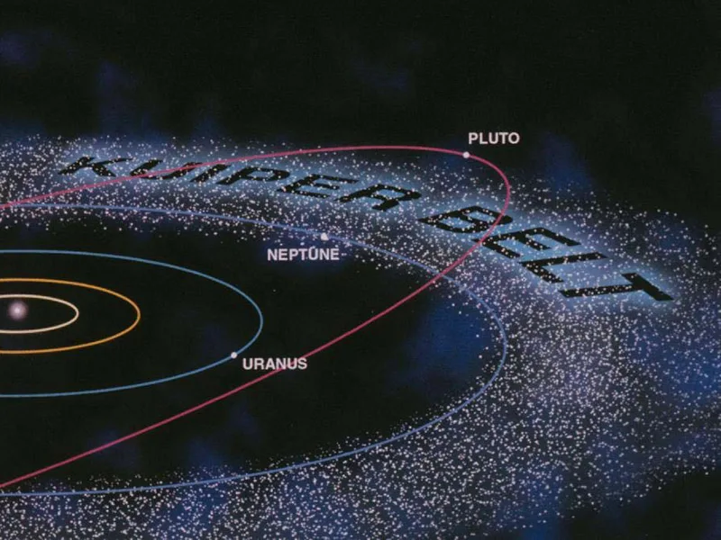

Main Asteroid Belt:
A region in the solar system located roughly between the orbits of Mars and Jupiter that is occupied by numerous irregularly shaped bodies called asteroids or minor planets

Translation:

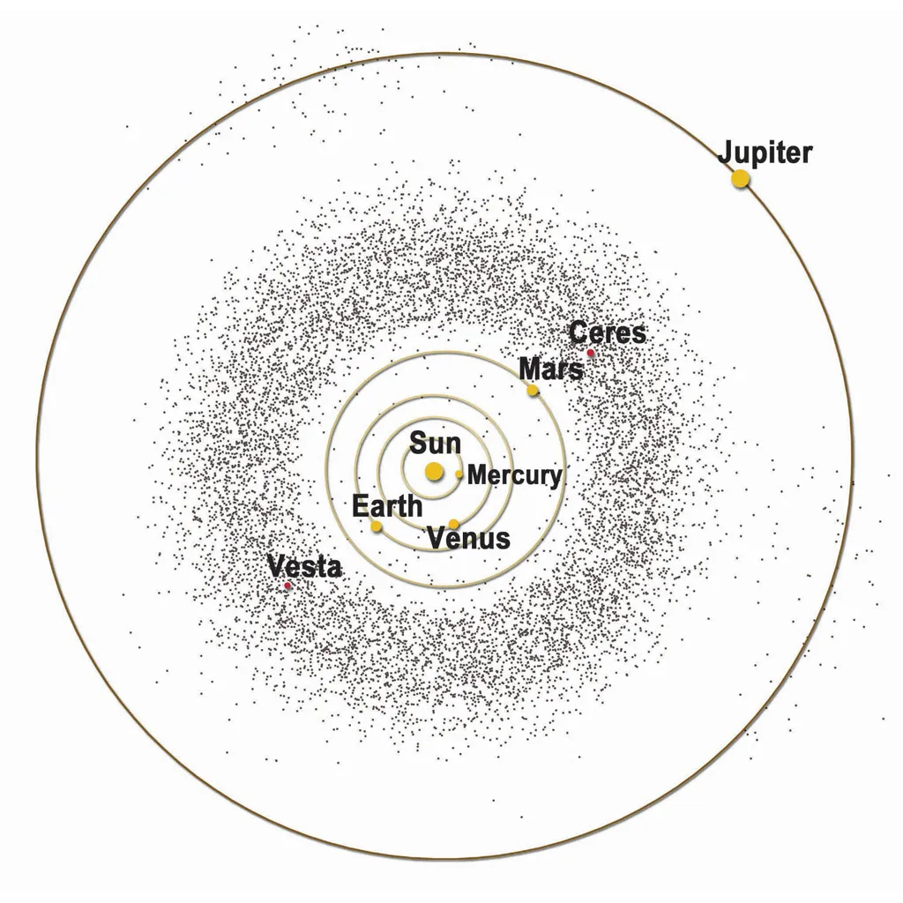

Reservoir:
A place where water is stored

Translation:

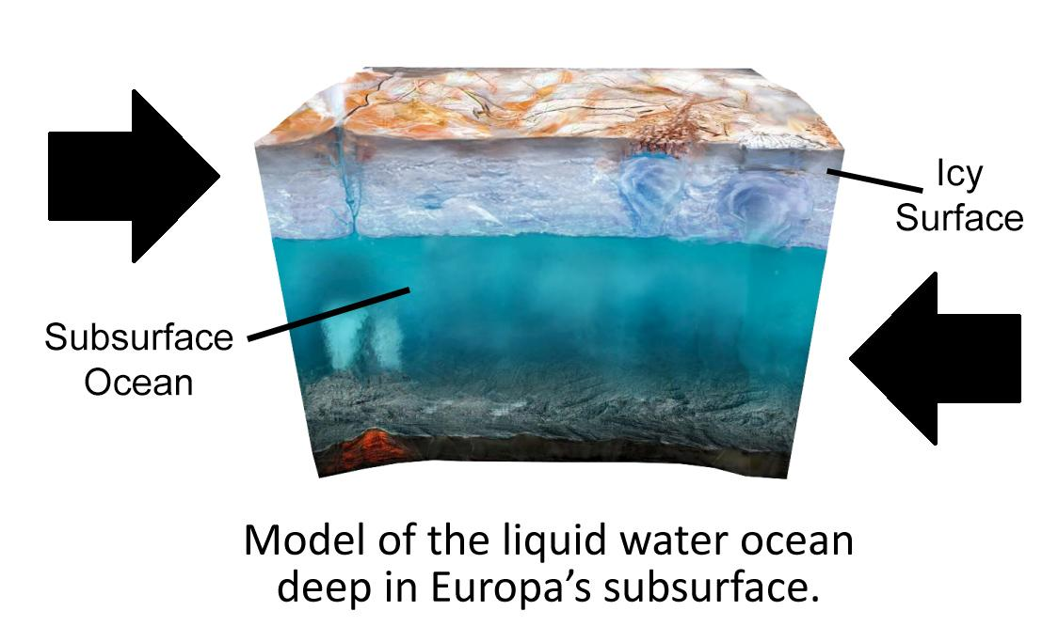

Salinity:
The concentration of salt dissolved in water

Translation:

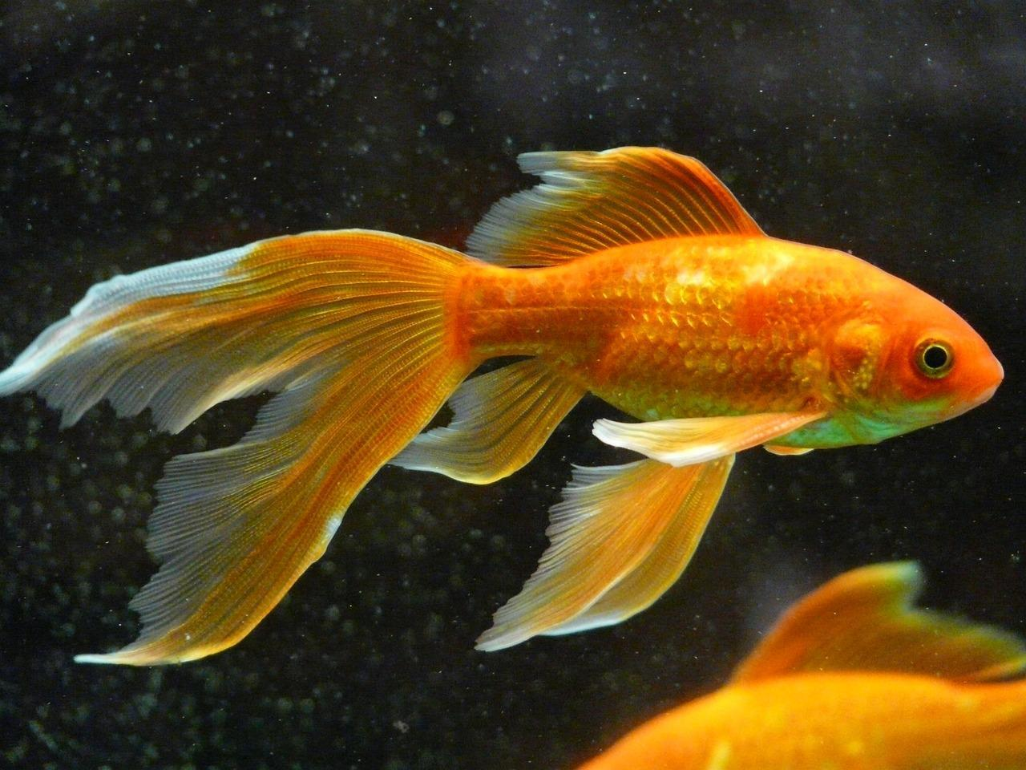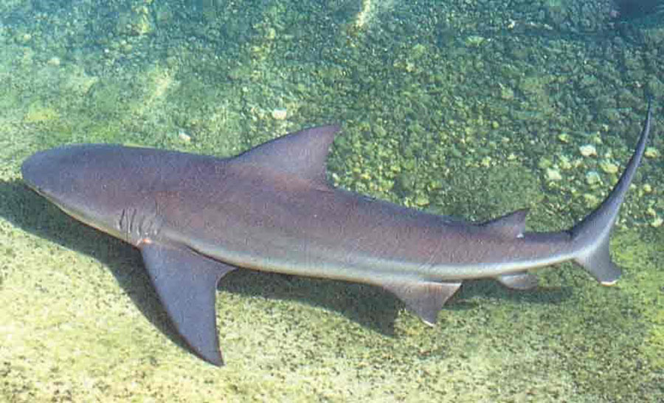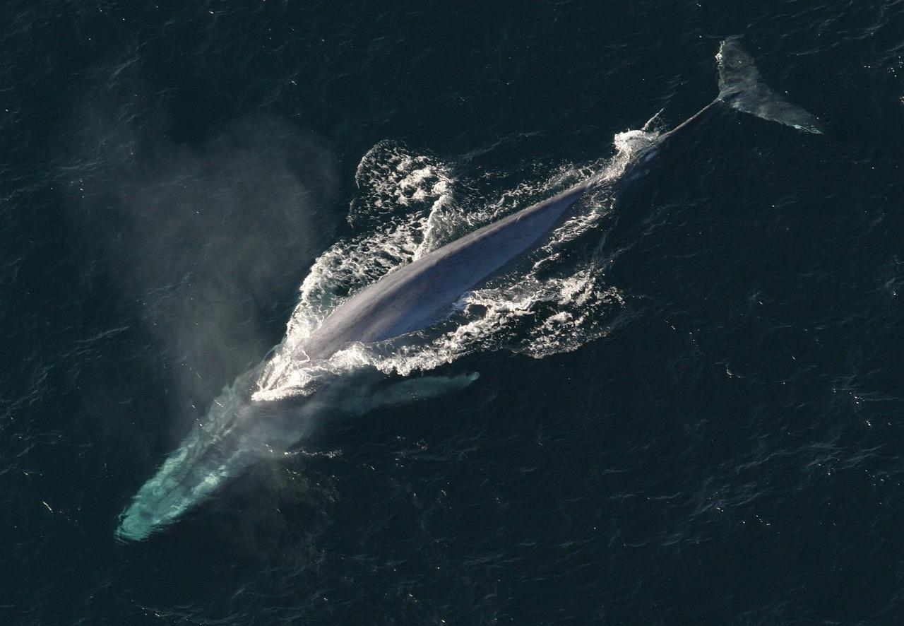

Subsurface:
Places under the surface of a planet

Translation:

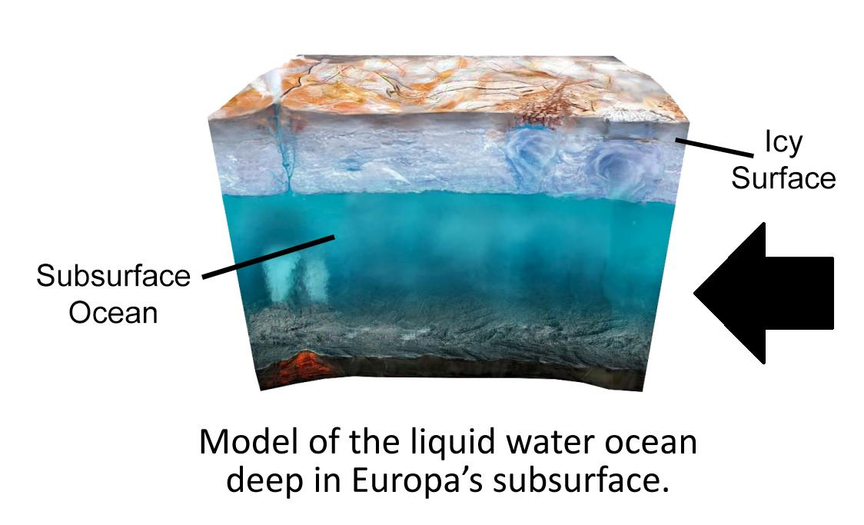

Surface:
The part of a planet exposed to the atmosphere or space

Translation:

